Year 11

Effective Revision: Maximise Your Potential

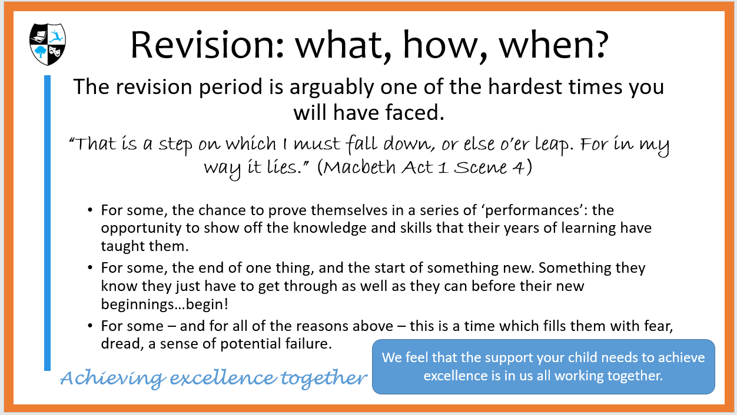

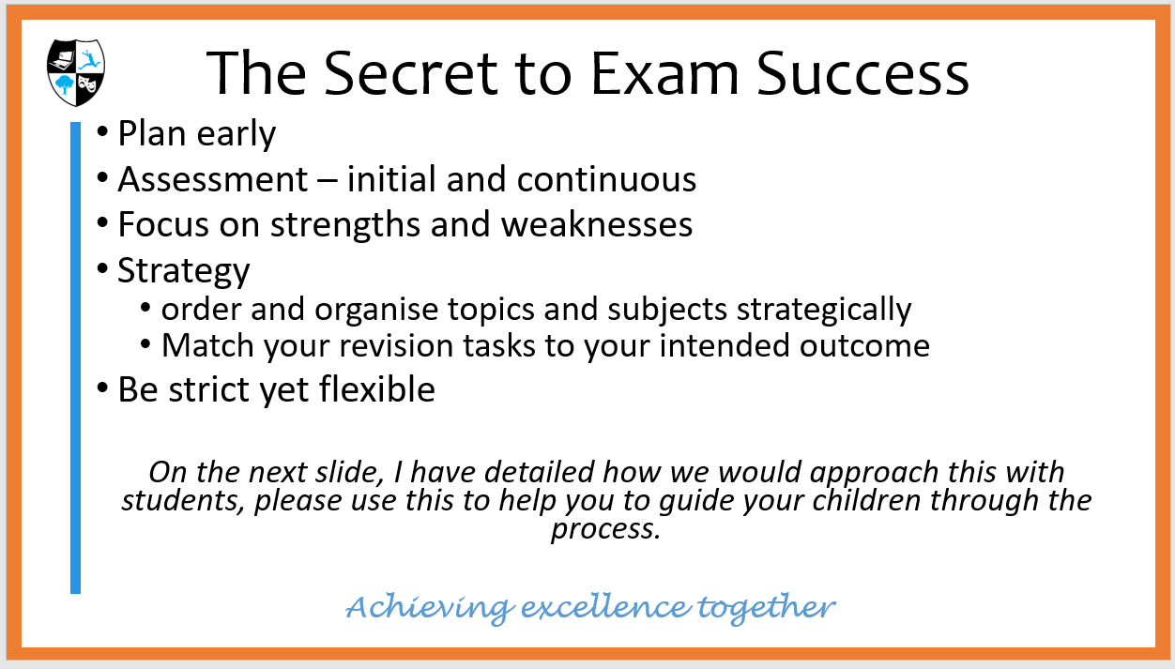

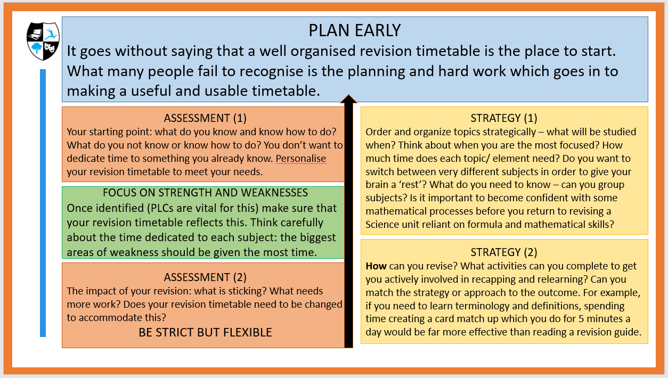
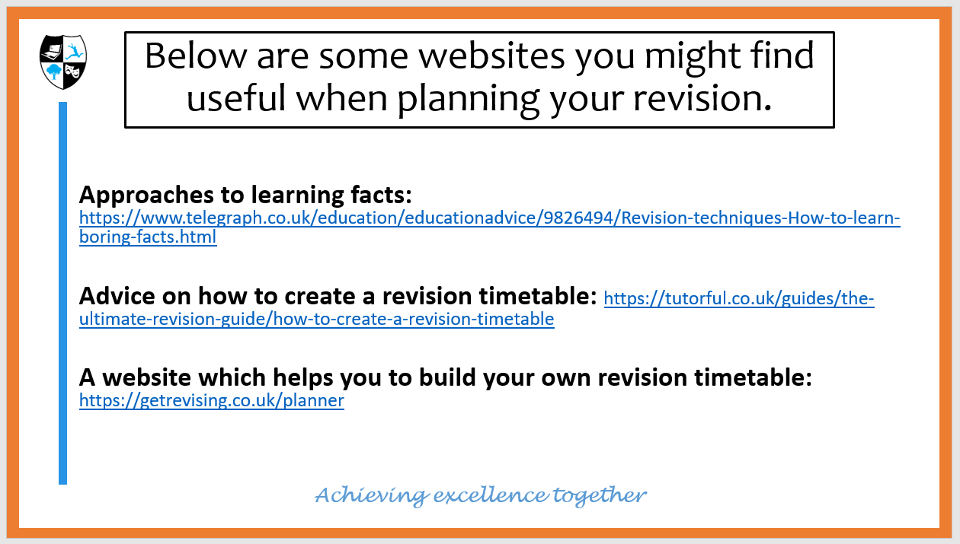

Resources from this afternoon’s sessions are all available here:
https://obhs.sharepoint.com/studentinfo/Y11Resources/SitePages/Home.aspx?RootFolder=%2Fstudentinfo%2FY11Resources%2FShared%20Documents%2F1%2E%202019%20%2D%2020%2FYear%2011%20Mock%20Revision%20Afternoon%2017%2E10%2E2019&FolderCTID=0x01200088E0D38B5BB7FD4F9C12329B8EBC0C95&View=%7BF1DC6E3F%2D64C6%2D40D4%2D8E42%2DBF801AAFC70B%7D
Student SharePoint Year 11 Revision Resources 1. 2019-20 Year 11 Revision Afternoon 17.10.2019
Distributed Practice
Distributed Practice is proven to be the best studying method for effective learning that lasts.

It is a learning technique where practice occurs in multiple short sessions over a long period of time, with an acceptable amount of space between each session.
For example, studying something during two different sessions with a break of a few days (or even hours) in between, rather than learning it all in one go.
Each learning session must focus on the same subject. Distributed practice is a well-known theory in cognitive psychology that’s used in a wide range of disciplines, from improving memory to physical activity to music.
The meaning of the term becomes quite clear when you split it up into its parts:
- Distributed = spread out
- Practice = to do something repeatedly so as to become proficient
The “spread out” aspect explains why distributed practice can also be referred to as spaced practice, spaced learning or spaced repetition. https://www.prodigygame.com/blog/distributed-practice/

So, how do I do it?

Once you have completed your GAP ANALYSIS and identified your priorities for revision, you need to plan a revision timetable which builds in opportunity for DISTRIBUTED PRACTICE in order to maximise your potential, and use your time (and brain) efficiently and effectively.

Gap Analysis and PLCs

You need to use a RAG-rated PLC (personal learning checklist) in order to identify the gaps in your knowledge. It is difficult to know what you don’t know when you don’t know it. Here’s where your teachers and the information available from exam boards comes in useful.

Personal Learning Checklists should list the knowledge and skills you need for a particular exam paper. These are available from your teachers for your mock exams in November. Once you have these lists, you need to RAG rate the list items.

RED = No (or very limited) knowledge and understanding/ No use of this skill;
AMBER = some, but inconsistent, knowledge and/ or evidence of this skill;
GREEN – confident and consistent. You know this. You use this.
Sometimes it can be difficult to self-assess accurately. You might think you have grasped something or can do something, but feedback from your teacher would suggest otherwise. Work with your teachers to complete your PLCs so that they are accurate!

Some PLCs will be knowledge/ information based:
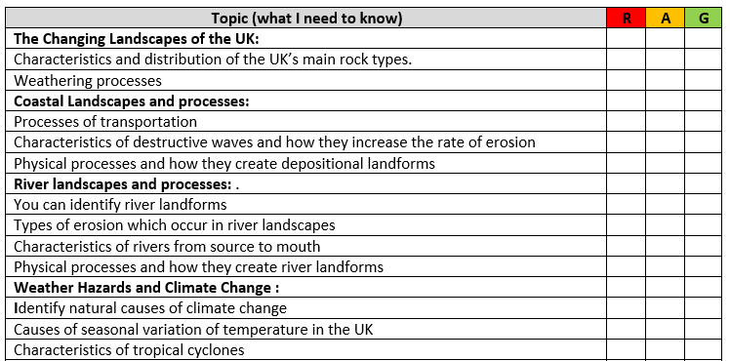
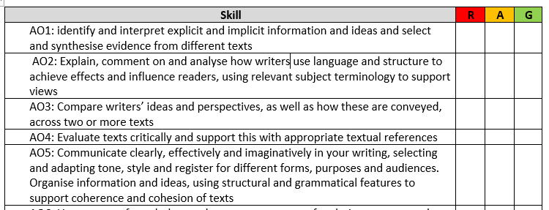
Others will be skills based:

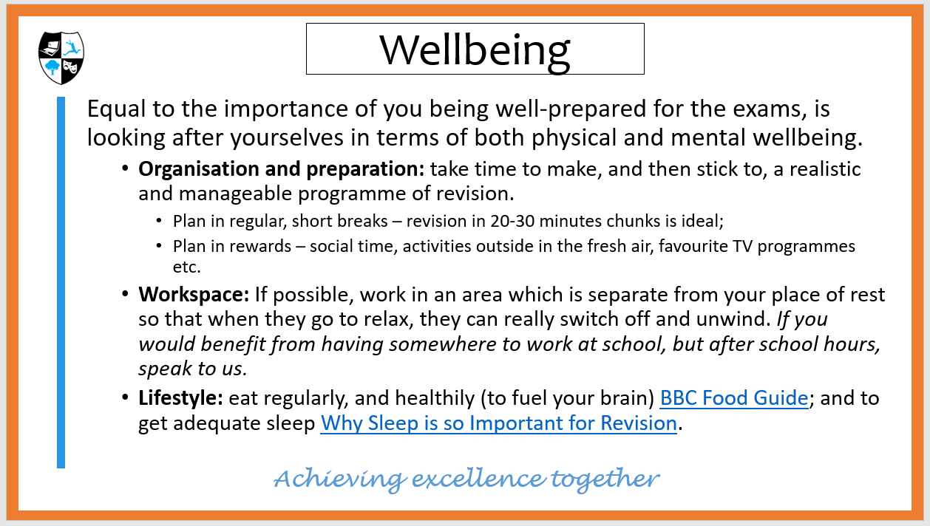

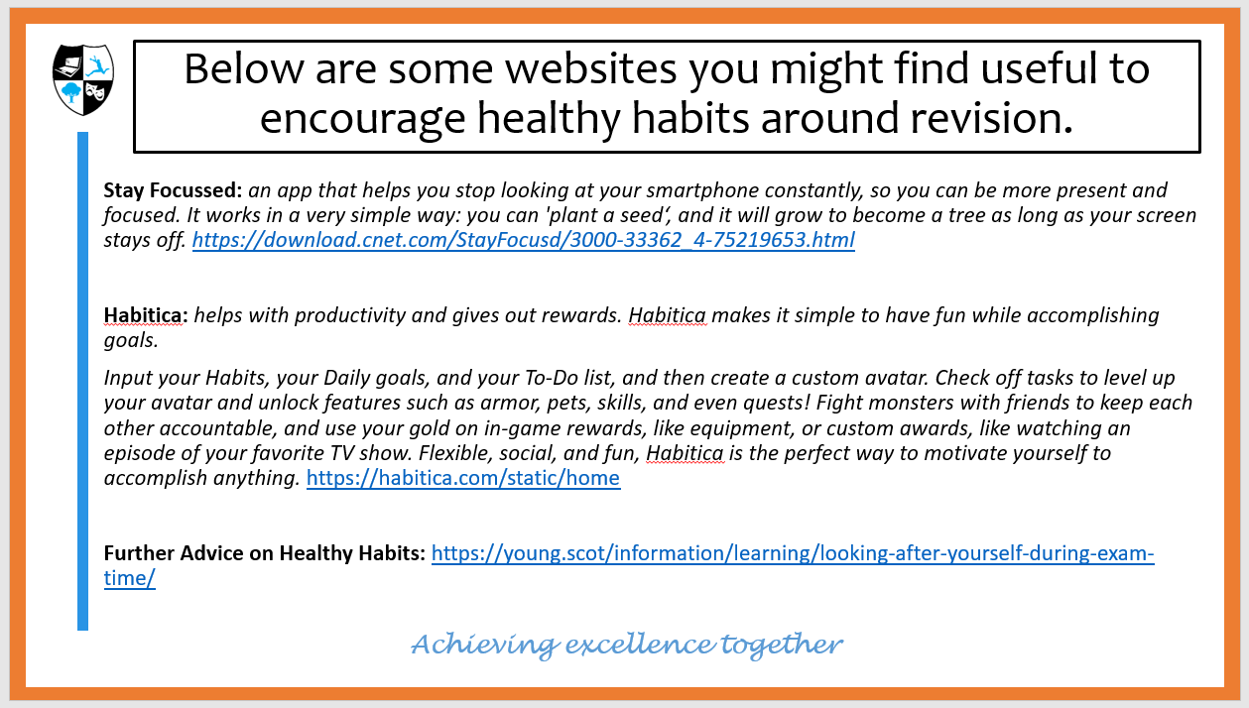

Practice Testing or Retrieval Practice

Retrieval Practice is a strategy to rehearse already learned information by trying to retrieve it from memory:
to locate the piece of information in your mind. It is based on what is known as “the testing effect”: the findings that future long-term memory performance is enhanced when content is practised by testing. Unfortunately, tests are often negatively associated with assessment and performance measurement. In retrieval practice tests are used as a tool for learning and to practise.

Retrieval practice tops a list of the most effective evidence-based learning strategies. It was shown to be effective for learners of all ages and subjects. Often people revise by rereading material. The major difference between re-reading and retrieval practice is that when you re-read, the information is presented to you in its entirety - it’s all there on the page in front of you, while with retrieval you have to search for the information in your own mind, following just a cue. https://theeducationhub.org.nz/wp-content/uploads/2019/08/The-benefits-of-retrieval-practice-in-learning.pdf
Revision Activities for Retrieval Practice

Quick Fire Quizzing:
- Use a resource from your teacher;
- Find a quick quiz online to get you started;
- Write your own quiz and quiz yourself/ get someone at home to quiz you;
- Play a game of quiz tennis. Sit down with a partner (A and B); Agree on a topic; A asks the first question; B answers and asks a question back; A answers and asks a question back…you get the idea! The first person to not answer, or not quiz loses.

Why did Macbeth kill King Duncan?

Because he had been told he would become King by the witches and wanted to ‘catch the nearest way’.

How is Macbeth presented at the very start of the play?
He is a brave warrior, and leader, who is highly respected by the King and his fellow soldiers.

INCREASE THE CHALLENGE
Strategies for self-quizzing:
Strategy 1a:
For learning key terminology, create yourself an electronic glossary (Term + definition and save this as a master copy). Now print different versions with terms/ definition blanked out. Your job is to fill in the missing words. Once the glossary is made, creating the quizzes is quick and easy.
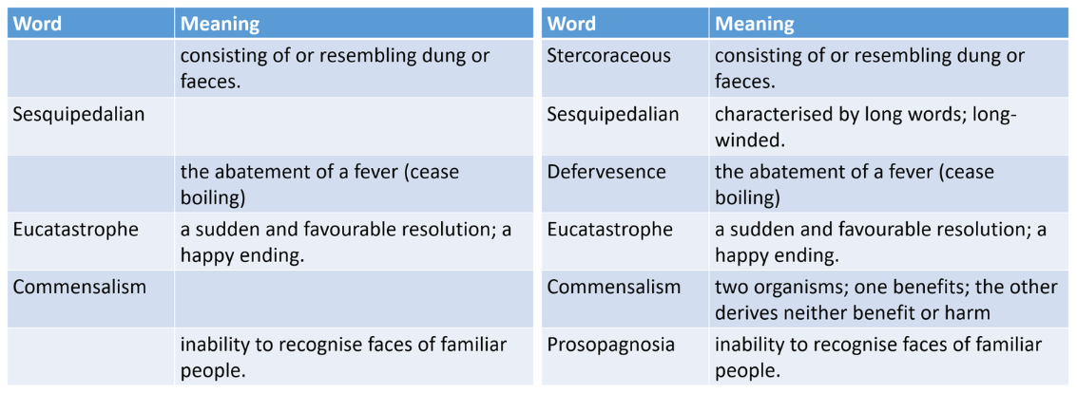

TRY IT FOR YOURSELF – CREATE YOUR GLOSSARY
This is already retrieval practice as you are having to draw on information from your memory.
Subject and Topic/ Unit
Key Term |  | Definition

Strategy 1b:
You can do exactly the same thing with labelled diagrams that you need to learn. If you don’t want to print lots of different versions out, just cover the label/ information with a post-it note. Don’t be tempted to cheat and look too early…give your brain a chance!
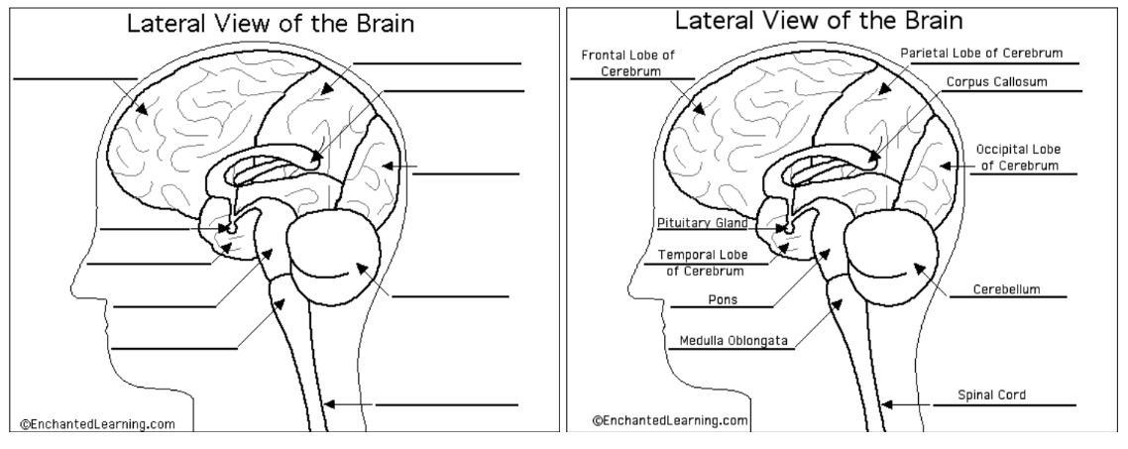

Strategy 1c:
You can also train yourself to memorise larger chunks of information like this too. Create a cloze exercise of a model paragraph or of key statements or quotes by blanking out the key words and phrases. Use spaced retrieval practice to fill in the blanks each time.

Force = mass x acceleration  A very simple example of how this would work, but you get the gist. | Retrieval Practice 1:  _____________ = mass x acceleration
Retrieval Practice 2:
_____________ = ____________ x acceleration
Retrieval Practice 3:
Force = ____________ x _____________

It works exactly the same with a longer piece of writing. This can be great to learn high quality responses to use in the exam.

Original Paragraph:
It is clear through his use of repetition and exclamatives that Shakespeare is presenting Macbeth in this extract as a character who is losing control. While at the start of the play he was a “noble” and “brave” warrior, he is presented here as weak, vulnerable and ‘trembling’: it is clear that while Lady Macbeth’s actions might be ensuring that he has not lost complete control of his subjects, he has certainly lost control of his mind. This moment was foreshadowed earlier by the dagger scene where his “heat oppressed mind” made him question, “Is this a dagger I see before me…?”. In this extract, he describes his guilt-ridden vision of Banquo’s ghost as an “unreal mockery”. The adjective ‘unreal’ almost seems to be used by Macbeth in a desperate attempt to convince himself that this is nothing to fear and to try to regain control, while the connotations of the word ‘mockery’ reflect Macbeth’s paranoia that while he is King, he is certainly not “…safely thus…” as the witches made it clear there are factors beyond his control.

Cloze Exercise Retrieval Practice 1:
It is clear through his use of (1) and exclamatives that Shakespeare is presenting Macbeth in this extract as a character who is (2 and 3). While at the start of the play he was a “noble” and “(4)” warrior, he is presented here as (5), vulnerable and ‘(6)’: it is clear that while Lady Macbeth’s actions might be ensuring that he has not lost complete control of his (7), he has certainly lost control of his (8).

Cloze Exercise Retrieval Practice 2:
It is clear through his use of (1) and (2) that Shakespeare is presenting Macbeth in this extract as a character who is (3 and 4). While at the start of the play he was a “(5)” and “(6)” warrior, he is presented here as (7), (8) and ‘(9)’: it is clear that while Lady Macbeth’s actions might be ensuring that he has not (10 phrase) of his (11), he has certainly lost control of his (12).

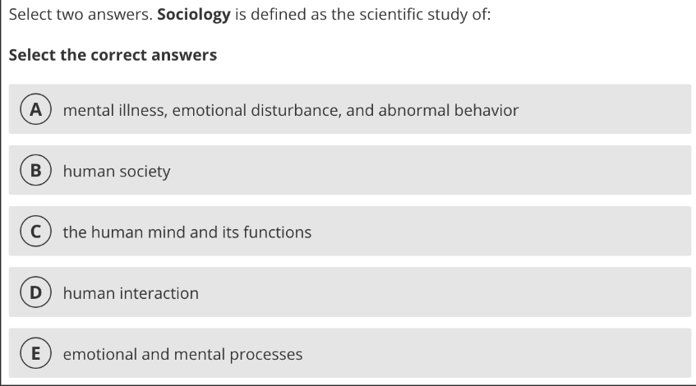
INCREASE THE CHALLENGE
Strategies for self-quizzing - FLASHCARDS
Strategy 2a – multiple choice quizzes:
On one side of your flashcard have key questions linked to your topic.
On the reverse have multiple choice answers.
For the first few times you might need to turn the card over to see the choices before you know the answer, but you should be able to answer the question without turning the card over if you use this strategy as one of your spaced retrieval practices.

Strategy 2b – key terms and definitions:
On one side of your flashcard have key term linked to your topic.
On the reverse have the definition/ explanation.
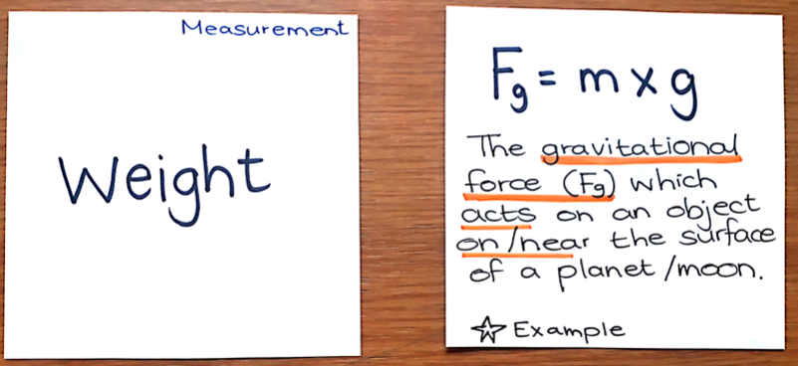
For the first few times you might need to turn the card over to remind you of the key words, but you should be able to recite the definition/ explanation without turning the card over if you use this strategy as one of your spaced retrieval practices.

Strategy 2c – images as triggers:
- On the front of the flashcard have an image which you learn to associate with the topic/ piece of information you are trying to remember. Through spaced retrieval practice, when you look at the image, you should be able to recall the information on the back of the card.
- Once you feel confident with the cards, you can lay them out picture side up and use them further:
  - Explain how one links to another, and so on;
  - Use them to explain cause and effect;
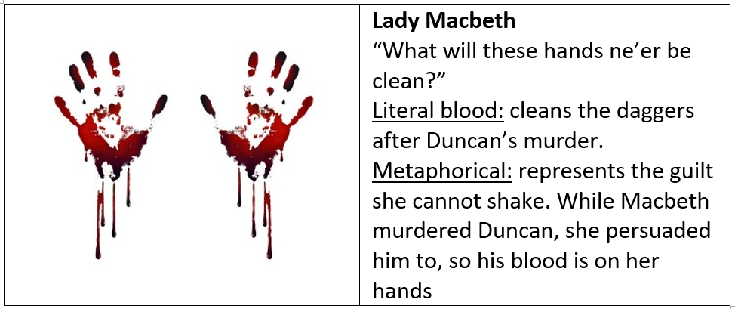
  - Using the images as a prompt re-tell the narrative/ give a detailed description of the topic.

Strategy 2d – flashcard diagrams:
On the front of the flashcard have the diagram minus the labels. On the back – the labelled version, or just a list of the key words (to increase the challenge). Try to remember as many of the labels as possible without turning the card over.
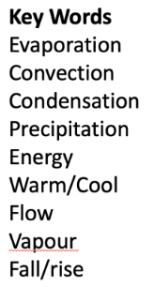
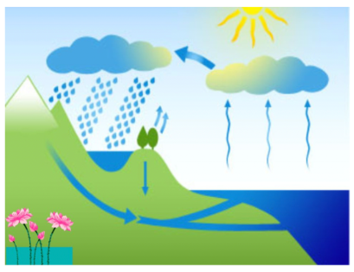

INCREASE THE CHALLENGE
Strategies for self-quizzing – POST-IT NOTES
A really effective way to use post-it notes…with the permission of the home-owner(!)…is to post-it note questions around the house.
If every time you want to go to the toilet, you have to answer the post-it note question on the door, you will re-visit (and therefore learn) this information quickly!
The great thing with post-it notes is that they are easy to replace. So, once you feel confident in your answer and are recalling it quickly and effortlessly, change the post-it note question.

GIVE YOUR MEMORY A HELPING HAND
Top Tips for Making Information More Memorable
Voice Notes
Some people find listening makes things much more memorable than reading – it’s also much more portable! You could record key facts and information. You could record yourself reciting a paragraphs with key words blanked (or silenced) out. You could record quiz questions to answer (in your head) while on the bus to school.

Mnemonics
If you are finding related or connected information tricky to remember, how about creating your own mnemonic. You can make it as silly as you like – as long as you remember it!
A mnemonic, also known as a memory aid, is a tool that helps you remember an idea or phrase with a pattern of letters, numbers, or relatable associations. Mnemonic devices include rhymes and poems, acronyms, songs, and other tools.

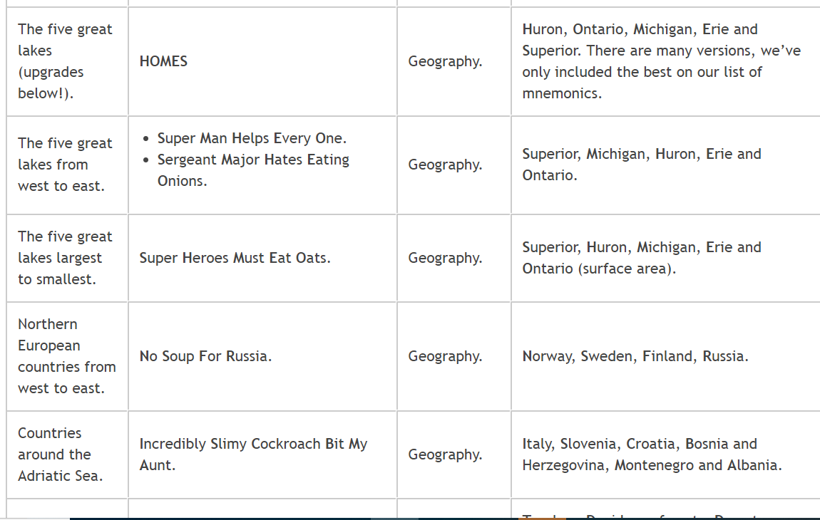

Story Time
Sometimes isolated pieces of information can be really difficult to remember, so why not create a memorable story to remind yourself of the links between them. Your brain is more likely to remember something which feels like it has a narrative to it than a string of words and phrases. https://www.theguardian.com/lifeandstyle/2012/jan/15/story-lines-facts

Let’s say I wanted to remember the first 10 chemical elements, I could use a story like this…

"A nuclear bomb (hydrogen) is about to go off, but it is lifted away by a (helium) balloon with a (lithium) battery. A lady called Beryl (beryllium) celebrates by cooking a boar (boron) over some coals (carbon). Just then a knight (nitrogen) in shining armour, who is riding past on an ox (oxygen), picks Beryl up and takes her to a florist (fluorine) where he buys her some (neon) flowers."

Mind Mapping, an Introduction

Mind mapping is a powerful tool to help you store and retrieve information. It is different to a spider diagram and has some very clear rules, which need to be used to maximise the effectiveness of the technique. With practice, care and attention, mind maps can be an extremely useful tool for revision.
The simple rules are:
Start with a central image, in the centre of a landscape orientated piece of paper;
Use colour for each branch;
Each branch contains one big idea or theme, written on the line, connected to sub ideas/knowledge;
Ensure the words are clear and capitalised where possible;
Use supporting images.

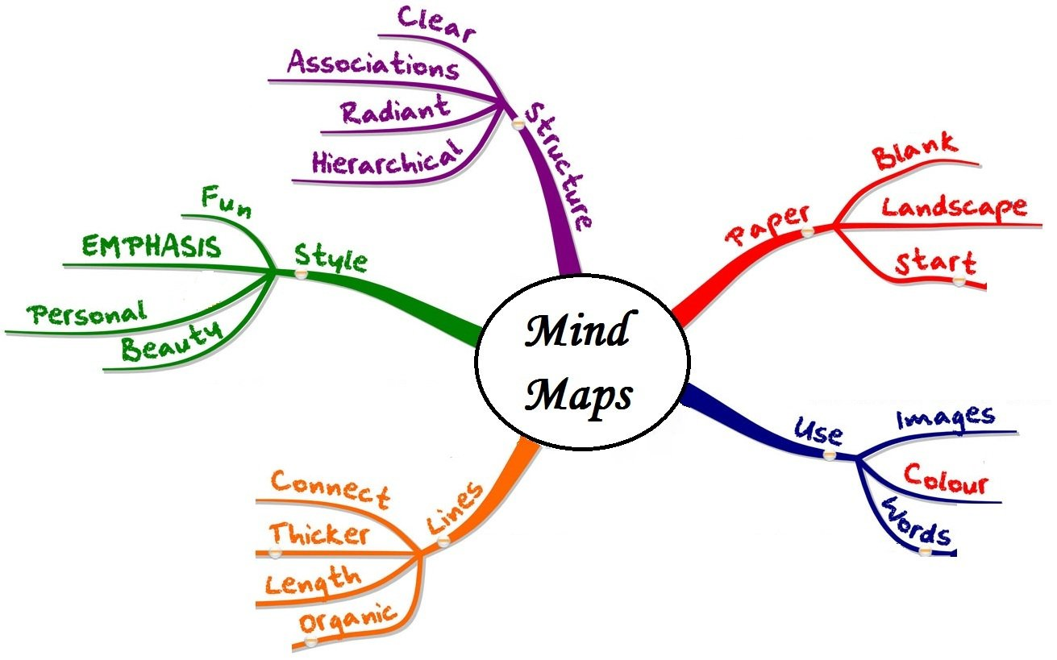

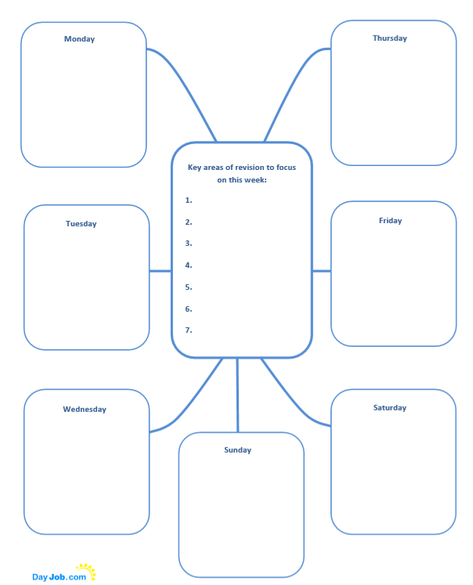
Use this weekly planner to identify your priorities. Fill each day in with the subjects and topics you will cover.
Example Revision Timetables

This style of planner is great for planning short bursts of revision after school. You should aim for 4 20-30 minute session per evening.

Time | Monday | Tuesday | Wednesday | Thursday | Friday

This style of planner would be great to use for October Half Term revision. You should plan social time and trips out into this too – we are not suggesting that every slot is a revision slot!

 | Monday | Tuesday | Wednesday | Thursday | Friday | Saturday | Sunday
8 am
9 am
10 am
11 am
12 pm
1 pm
2 pm
3 pm
4 pm
5 pm
6 pm
7 pm
8 pm

PLCs (Personal Learning Checklists).

Use these to identify the gaps in your knowledge, then target them in your revision!
We have included PLCs for English, Maths, Science, and History as these are the most studied subjects. Geography PLCs booklets will be handed out by your teachers. Electronic copies of all PLCs can be found in the folder on SharePoint
(Student SharePoint Year 11 Revision Resources 1. 2019-20 PLCs) or you can ask your subject teacher for a hard copy.
ENGLISH LITERATURE
Exam | Duration | Marks available | % of GCSE | Topics/ content
English Literature Paper 1 | 1 hour 45 minutes | 64 | 40% of English Literature GCSE | - Shakespeare – ‘Macbeth’;  - 19th Century Novel – ‘A Christmas Carol’.
English Literature Paper 2 | 2 hours 15 minutes | 96 | 60% of English Literature GCSE | - ‘An Inspector Calls’  - Poetry comparison from the AQA Anthology: Power and Conflict.  - Unseen poem analysis and comparison

Personal Learning Checklists
Topic (what I need to know) | R | A | G
The characters, plot, setting and themes of ‘Macbeth’
Relevant information about the 16th century (which I can link to Macbeth).
The characters, plot, setting and themes of ‘A Christmas Carol’
Information about the 19th century (which I can link to A Christmas Carol)
The characters, plot, setting and themes of ‘An Inspector Calls’
Information about the 20th century (which I can link to An Inspector Calls)
The characters, settings or events in the Poems listed in the Power and Conflict section of the Anthology
Poetic techniques: the terminology and typical use of each technique

Skill | R | A | G
AO1: Use quotes to support ideas and interpretations
AO1: Give a developed response to the task and the text
AO2: Clearly explain the writer’s choice of language with use of terminology
AO2: Explore the effects of the writer’s choice of language
AO3: Explore links to ideas, context, message and whole text.

ENGLISH LANGUAGE
Exam | Duration | Marks available | % of GCSE | Topics/ content
English Language Paper 1: Explorations in creative reading and writing. | 1 hour 45 minutes | 80 | 50% of English Language GCSE | Section A: Reading  one literature fiction text  - Identify information in the text by listing four things  - Explain how the writer uses language to present ideas.  - Explain how the writer uses structure to present ideas.  - Evaluate the text by saying to what extent you agree with a given statement.  Section B: Writing  descriptive or narrative writing
English Language Paper 2:  Writers’ viewpoints and perspectives. | 1 hour 45 minutes | 80 | 50 % of English Language GCSE | Section A: Reading  one non-fiction text and one literary non-fiction text  - Identify information in the text by giving true/false responses  - Write a summary of each text.  - Explain how the writer uses language to present ideas.  - Compare how the writers present ideas and perspectives.  Section B: Writing  writing to present a viewpoint

English Language Personal Learning Checklists
Topic (what I need to know) | R | A | G
Language techniques – the name, common usage and effect of each
Structural techniques – the name, common usage and effect of each
Punctuation – a range of punctuation to use for effect in my own writing
Read a wider range of 19th and 20th century texts to be familiar with language and content
Develop a wide vocabulary with accurate spelling

Skill | R | A | G
AO1: identify and interpret explicit and implicit information and ideas and select and synthesise evidence from different texts
AO2: Explain, comment on and analyse how writers use language and structure to achieve effects and influence readers, using relevant subject terminology to support views
AO3: Compare writers’ ideas and perspectives, as well as how these are conveyed, across two or more texts
AO4: Evaluate texts critically and support this with appropriate textual references
AO5: Communicate clearly, effectively and imaginatively in your writing, selecting and adapting tone, style and register for different forms, purposes and audiences. Organise information and ideas, using structural and grammatical features to support coherence and cohesion of texts

Mathematics
Exam | Duration | Marks available | % of GCSE | Topics/ content
Maths Paper 1  Non-Calculator | 1 hour 30 minutes | 80 | 33.3% of Maths GCSE | Number, Algebra, Geometry and measures, Probability and Statistics, Ratio and Proportion.
Maths Paper 2  Calculator | 1 hour 30 minutes | 80 | 33.3% of Maths GCSE | See above
Maths Paper 3  Calculator | 1 hour 30 minutes | 80 | 33.3% of Maths GCSE | See above

Personal Learning Checklists
Topic (what I need to know) | R | A | G
Every topic in the Maths GCSE actual exam will be assessed in the mock exam.
Please refer to the GCSE Mathematics Higher / Foundation checklist your teacher will have given you. If you do not have one see Mr Foreman

Skill | R | A | G
Memorise and apply key facts and formulae.
Confident in written methods (ie, without a calculator) such as multiplication, division, addition and subtraction of whole numbers, decimals and fractions.
Understand and be able to apply the content in the GCSE Mathematics Higher / Foundation checklist.
As above but be able to recognise which concept needs to be applied in context or multi-stage problems to solve complex problems.

SCIENCE TRILOGY – DOUBLE AWARD
Exam | Duration | Marks available | % of GCSE | Topics/ content
Biology Paper 1 | 75 minutes | 70 | 16.7% | Biology topics 1–4: Cell Biology; Organisation; Infection and response; and Bioenergetics.
Biology paper 2 | 75 minutes | 70 | 16.7% | Biology topics 5–7: Homeostasis and response; Inheritance, variation and evolution; and Ecology.
Chemistry paper 1 | 75 Minutes | 70 | 16.7% | Chemistry topics 8–12: Atomic structure and the periodic table; Bonding, structure, and the properties of matter; Quantitative chemistry; Chemical changes; and Energy changes.
Chemistry paper 2 | 75 minutes | 70 | 16.7% | Chemistry topics 13–17: The rate and extent of chemical change; Organic chemistry; Chemical analysis; Chemistry of the atmosphere; and Using resources.
Physics paper 1 | 75 minutes | 70 | 16.7% | Physics topics 18–21: Energy; Electricity; Particle model of matter; and Atomic structure.
Physics paper 2 | 75 minutes | 70 | 16.7% | Physics topics 22–24: Forces; Waves; and Magnetism and electromagnetism.

Personal Learning Checklists
Topic (what I need to know) | R | A | G
1. Cell biology
2. Organisation
3. Infection and response
4. Bioenergetics
5. Homeostasis and response
6. Inheritance, variation and evolution
7. Ecology
8. Atomic structure and the periodic table
9. Bonding, structure, and the properties of matter
10. Quantitative chemistry
11. Chemical changes
12. Energy changes
13. The rate and extent of chemical change
14. Organic chemistry
15. Chemical analysis
16. Chemistry of the atmosphere
17. Using resources
18. Energy
19. Electricity
20. Particle model of matter
21. Atomic structure
22. Forces
23. Waves
24. Magnetism and electromagnetism

Skill | R | A | G
Be able to extract data from a table or graph to support a conclusion or suggestion.
Structure longer questions to gain the maximum number of marks.
Name scientific equipment and be able to describe how to use it safely.
Use scientific terms to explain your ideas.
Use concept diagrams to express and idea.
Find and explain patterns in data and observations.

BIOLOGY GCSE
Exam | Duration | Marks available | % of GCSE | Topics/ content
Biology Paper 1 | 1 hour 45 minutes | 100 | 50% | Topics 1–4: Cell biology; Organisation; Infection and response; and Bioenergetics.
Biology paper 2 | 1 hour 45 minutes | 100 | 50% | Topics 5–7: Homeostasis and response; Inheritance, variation and evolution; and Ecology.

Personal Learning Checklists
Topic (what I need to know) | R | A | G
1. Cell biology
2. Organisation
3. Infection and response
4. Bioenergetics
5. Homeostasis and response
6. Inheritance, variation and evolution
7. Ecology
8. Key ideas and experimental procedure

Skill | R | A | G
Be able to extract data from a table or graph to support a conclusion or suggestion.
Structure longer questions to gain the maximum number of marks.
Name scientific equipment and be able to describe how to use it safely.
Use scientific terms to explain your ideas.
Use concept diagrams to express and idea.

CHEMISTRY GCSE
Exam | Duration | Marks available | % of GCSE | Topics/ content
Chemistry paper 1 | 1 hour 45 minutes | 100 | 50% | Topics 1–5: Atomic structure and the periodic table; Bonding, structure, and the properties of matter; Quantitative chemistry, Chemical changes; and Energy changes.
Chemistry paper 2 | 1 hour 45 minutes | 100 | 50% | Topics 6–10: The rate and extent of chemical change; Organic chemistry; Chemical analysis, Chemistry of the atmosphere; and Using resources.

Personal Learning Checklists
Topic (what I need to know) | R | A | G
1. Atomic structure and the periodic table
2. Bonding, structure, and the properties of matter
3. Quantitative chemistry
4. Chemical changes
5. Energy changes
6. The rate and extent of chemical change
7. Organic chemistry
8. Chemical analysis
9. Chemistry of the atmosphere
10. Using resources

Skill | R | A | G
Be able to extract data from a table or graph to support a conclusion or suggestion.
Structure longer questions to gain the maximum number of marks.
Name scientific equipment and be able to describe how to use it safely.
Use scientific terms to explain your ideas.
Use concept diagrams to express and idea.
Find and explain patterns in data and observations.
Know required practical methods and the questions that might be applied to them.

PHYSICS GCSE
Exam | Duration | Marks available | % of GCSE | Topics/ content
Physics paper 1 | 1 hour 45 minutes | 100 | 50% | Topics 1-4: Energy; Electricity; Particle model of matter; and Atomic structure.
Physics paper 2 | 1 hour 45 minutes | 100 | 50% | Topics 5-8: Forces; Waves; Magnetism and electromagnetism; and Space physics.

Personal Learning Checklists
Topic (what I need to know) | R | A | G
1. Energy
2. Electricity
3. Particle model of matter
4. Atomic structure
5. Forces
6. Waves
7. Magnetism and electromagnetism
8. Space physics

Skill | R | A | G
Be able to extract data from a table or graph to support a conclusion or suggestion.
Structure longer questions to gain the maximum number of marks.
Name scientific equipment and be able to describe how to use it safely.
Use scientific terms to explain your ideas.
Use concept diagrams to express and idea.
Find and explain patterns in data and observations.
Know required practical methods and the questions that might be applied to them.

HISTORY
Exam | Duration | Marks available | % of GCSE | Topics/ content
Paper 1: Thematic study and the historic environment | 1 hour 15 minutes | 52 | 30% | Medicine in Britain, c1250–present and The British sector of the Western Front, 1914–18.
Paper 2: British Depth Study and Period Study | 1 hour 45 minutes | 64 | 40% | Early Elizabethan England, 1558–88.  Superpower relations and the Cold War, 1941-1991.
Paper 3: Modern Depth Study | 1 hour 20 minutes | 52 | 30% | Weimar and Nazi Germany, 1918–39.

Personal Learning Checklist for the Mock Exam: Weimar and Nazi Germany, 1918-1939

Part 1: Knowledge and understanding
Section A: Weimar Germany 1918--1929 | R | A | G
Early problems of the Weimar Republic: abdication of the Kaiser; Spartacist Uprising; revolts, strengths & weaknesses of the Weimar Constitution.
Early problems of the Weimar Republic: Treaty of Versailles; Kapp Putsch; Occupation of the Ruhr and hyperinflation.
Recovery under Stresemann: Rentenmark; Dawes Plan; Young Plan; Locarno Pact; League of Nations; Kellogg-Briand Pact; impact of recovery.
Social change, 1924-1929: standards of living for workers; improvements for women; cultural changes.

The Depression & the failure of the Weimar government to deal with it: Wall Street Crash; unemployment; increased taxes; cuts to unemployment benefit.
The Nazi Party to 1929: setting up of the Nazi Party; Munich Putsch and consequences; Nazi Party strengths & weaknesses to 1929.
The Nazi Party 1929-1933: Nazis & the Depression-how they won support; election gains; how Hitler became Chancellor.
Section B: Nazi Germany 1933-1939 | R | A | G
How Hitler changed Germany from a democracy to a dictatorship: Reichstag Fire; Enabling Law; removal of opposition; Night of the Long Knives; death of Hindenburg.
Main features of the dictatorship in Germany: Law & order; persecution of Jews & other groups; women; the Church; indoctrination of children; propaganda.
Opposition to the Nazis: the Protestant Church; the Catholic Church; Edelweiss Pirates; Swing Youth; how effective?
Did Germans benefit from Nazi rule? Increasing employment & self-sufficiency; German Labour Front & Strength through Joy.

Part Two: Exam Question Skills
Type of exam question | R | A | G
Source inference questions (4)
Explain why questions (12)
How useful questions (8 )
Difference in the interpretations questions (4)
Reasons for the different interpretations (4)
How far do you agree with the interpretation questions (16 & 4 SPaG)

