These are pitch maps produced by Hawkeye to show where bowlers, in cricket, have pitched their deliveries.
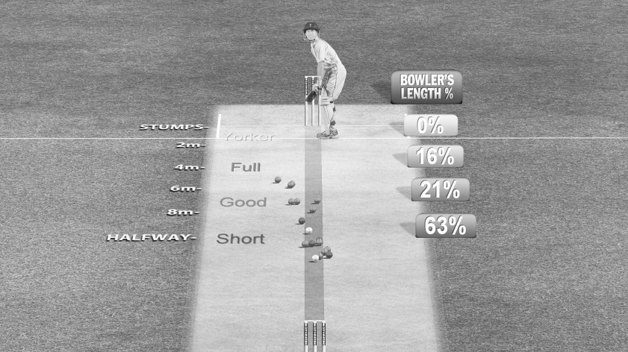
Bowler 1

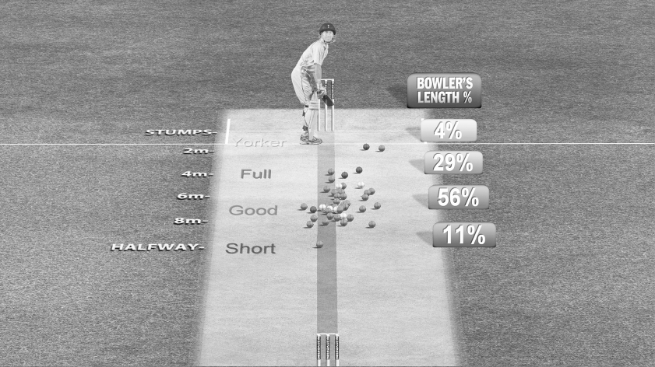
Bowler 2

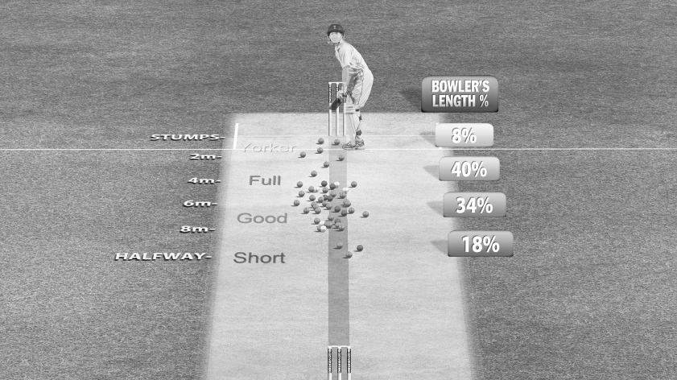
Bowler 3
- Interpret the data: Which bowler bowled the highest percentage of short balls?

- Present the data as three pie charts.

Key

- Analyse the data: How would this kind of feedback on performance be useful to a bowler?

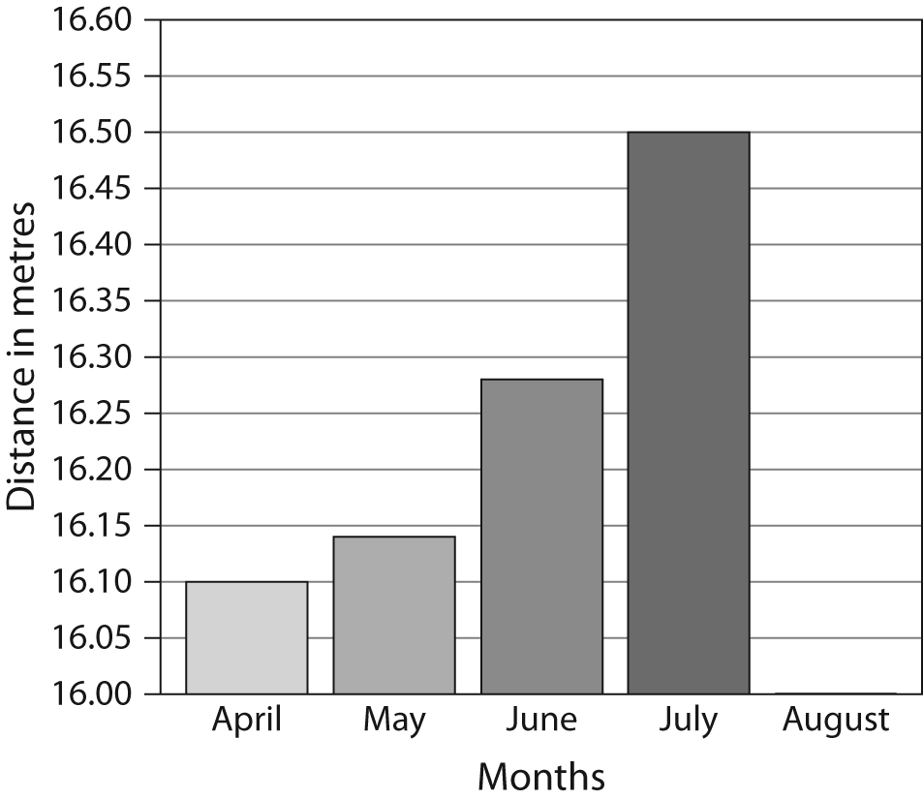
A bar graph showing the personal bests of a young triple jumper, by month.
The graph shows how the personal best of a young triple jumper developed through an athletics season.
- Interpret the graph: Is the current trend upwards or downwards? Explain your answer.

- Present the data by producing a line graph showing the same information as the bar graph.



- Analyse the data: Make a prediction based on your analysis. What would you expect August’s data to show?

