6 Mark question.

Explain two functions of the cardiovascular system that enables a long distance cyclist to perform well in their event. (6 marks)

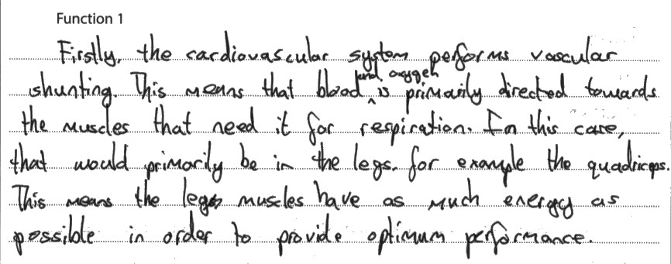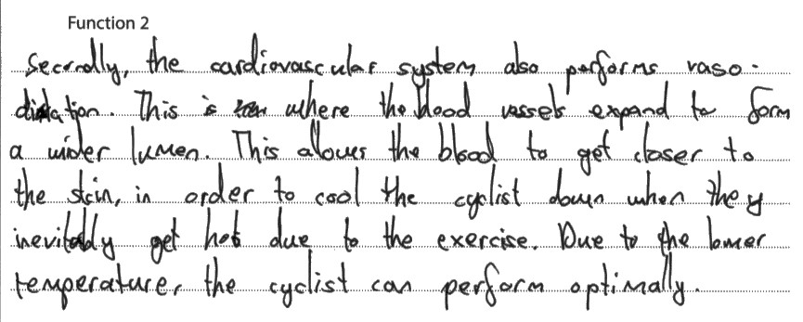

This response gains four marks. In both cases the ‘missing’ marks are for the impact on performance. ‘To perform optimally’ was considered too vague for credit, something a little more specific to show what this meant was required, e.g. delayed fatigue or to prevent the cyclist overheating and the impact this could have.

- Highlight were this candidate gained the four marks.

- Now write your own answer adding in what they have missed to gain the full 6 marks.

