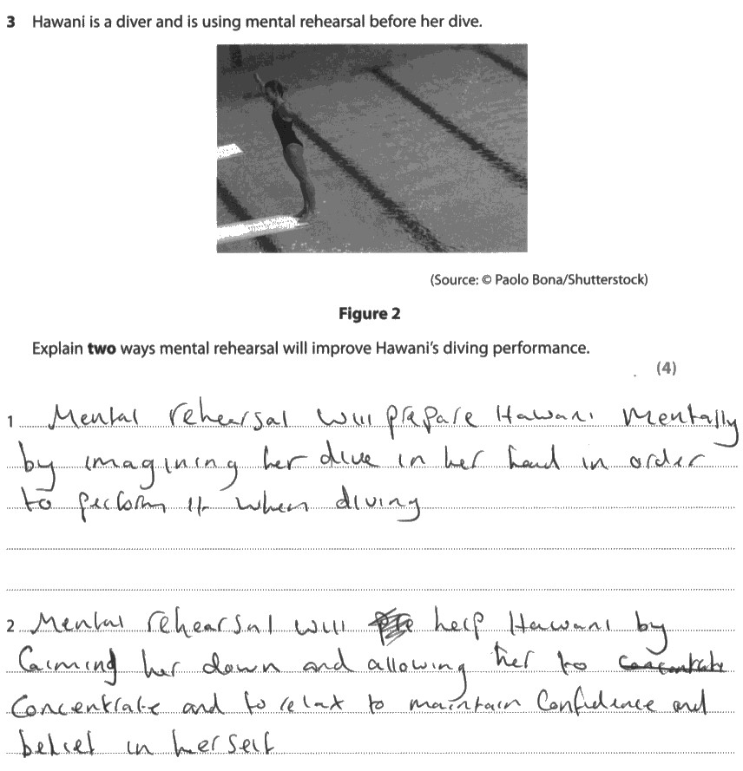

The candidate identifies two benefits of mental rehearsal – imagining her dive in her head and calming her down.
However, neither makes an appropriate application, which is linked to how this improves performance in diving. Therefore, it was only awarded 2 marks.
Task
Using the information above and your knowledge of mental rehearsal, write an answer which will gain the full 4 marks.

