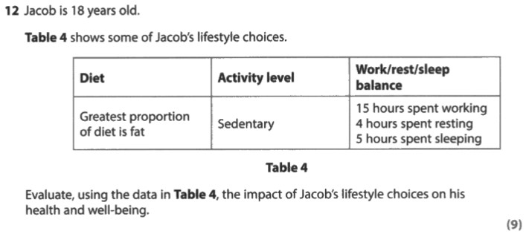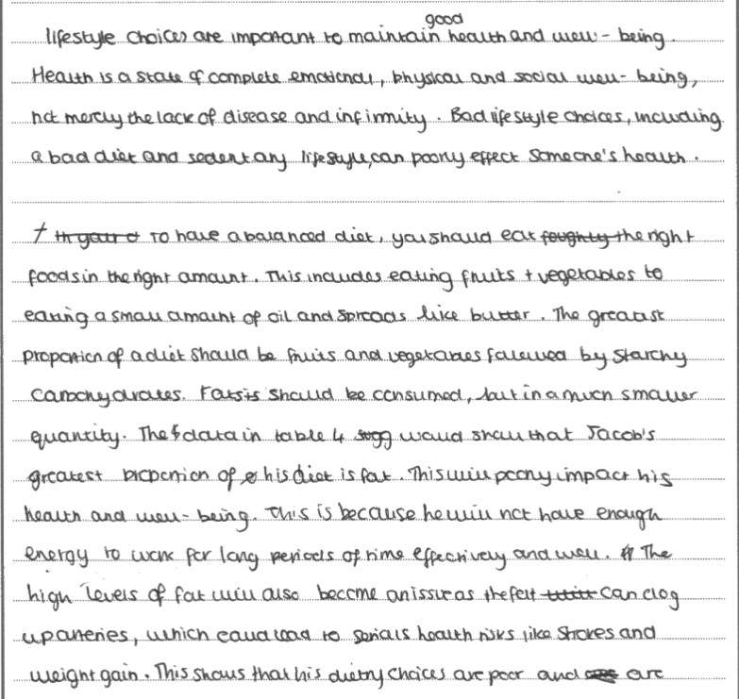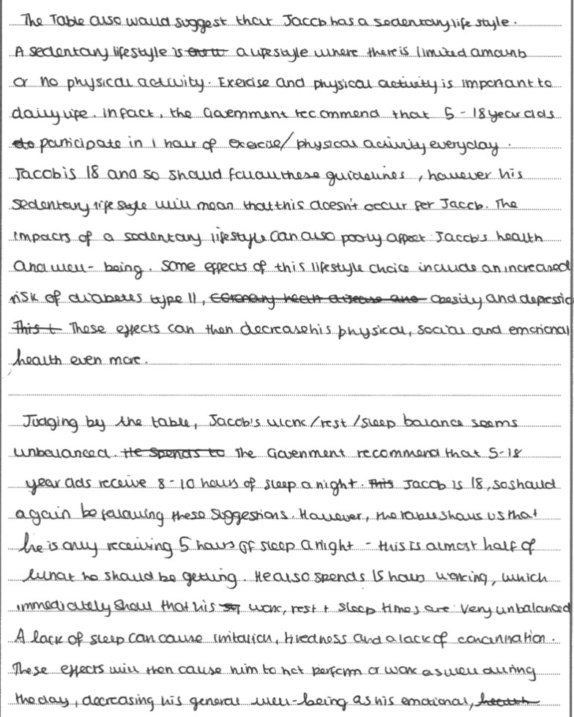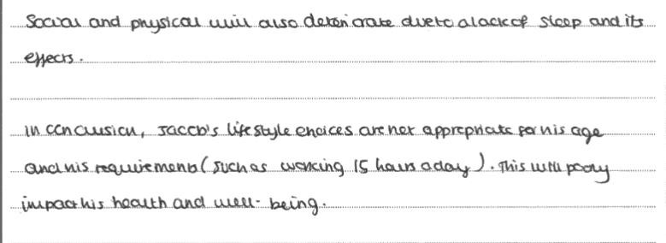

Task

Read the answer to the 9 mark question. Using 3 different colours mark where this candidate would have been award A01, A02 and A03 marks.
What mark would you give it overall and is there anything they have missed and could have added?

