Philosophy and Ethics GCSE
Exam Board: OCR | 2 Papers (50% each)  2 hours each;  126 marks (inc 6 SPAG) both papers | https://www.ocr.org.uk/qualifications/past-papers/

Skills students are examined on:
AO1 Knowledge and Understanding | AO2 Analysis and Evaluation
Stating and explaining in depth the reasons for why a specific belief is held or a practice is carried out.  Demonstrating good and relevant knowledge of the diversity of beliefs, teachings and practices within religions.  Demonstrating understanding of influences and impact of modern and traditional ways of life. | Analysis in response to issues within the modern world.  Well structured and organised analysis presented in a structured manner.  A balanced discussion and judgement made on the issue.  Reaching a balanced conclusion.
Useful websites for content:
https://www.bbc.com/bitesize/examspecs/zy7spbk
https://revisionworld.com/gcse-revision/rs-religious-studies

Suggested revision activities to help your child prepare for the Philosophy and Ethics exam:
Create a glossary of key terms. Highlight, define, use the term in a sentence. Test your child using their own glossary, ask them to define the key terms from the definitions they have created.
Learning key terms is key. There are many which may appear on the exam paper. Students won’t be able to answer the question if they don’t understand the words in the question.
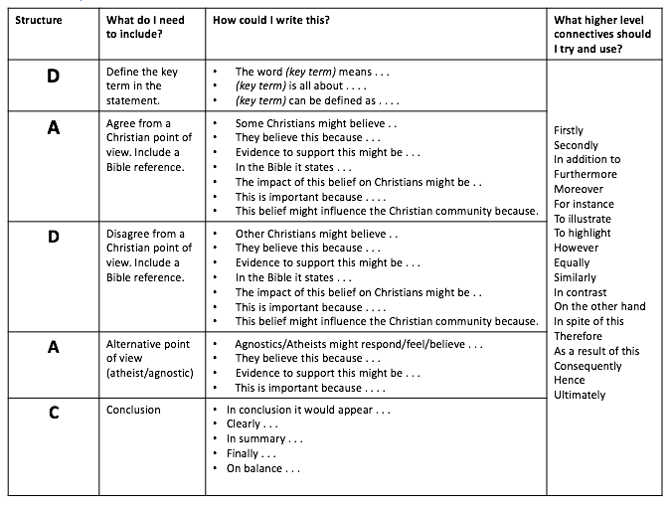
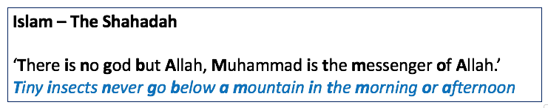
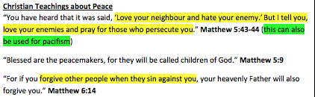
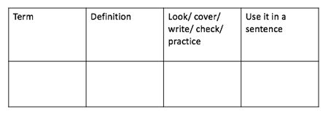
Create revision cards with quotes for each topic. Try cutting up the quotes, jumbling them up, then get your child to put them together correctly. Create some visual images or a series of dingbats. Design a mnemonic.
Extended Writing

Your child needs to be able to discuss a topic. Practise using the DADAC framework and sentence starters, this will speed up their responses. Try together talking through how you might start off an answer to a 15 mark question. What different responses can you think of? Bullet point some ideas both for and against an issue. Discuss if some points are more important than others? How can you start a conclusion?

Once confident, try timing your child’s written responses, they are aiming for 1 mark a minute.

Learning sources of wisdom and authority. The don’t need to know the quotes word for word, but they do need to be able to mention and explain them in an exam question. explain

