Logging in

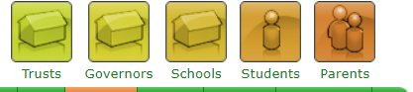

- Search for www.go4schools.com/parents or visit the OBHS website and click on the link which is found in the Parents Section

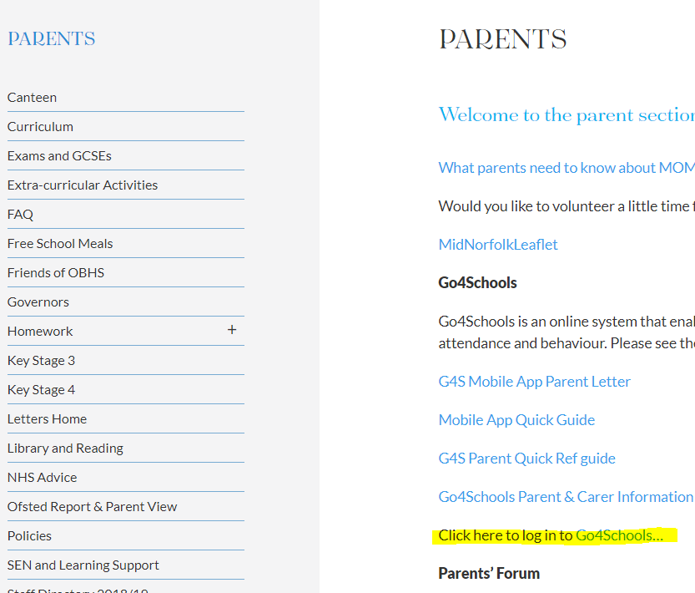

- Click on First-time User? or Forgotten your Password? where appropriate and enter your email address. This must be the email address registered with the school.
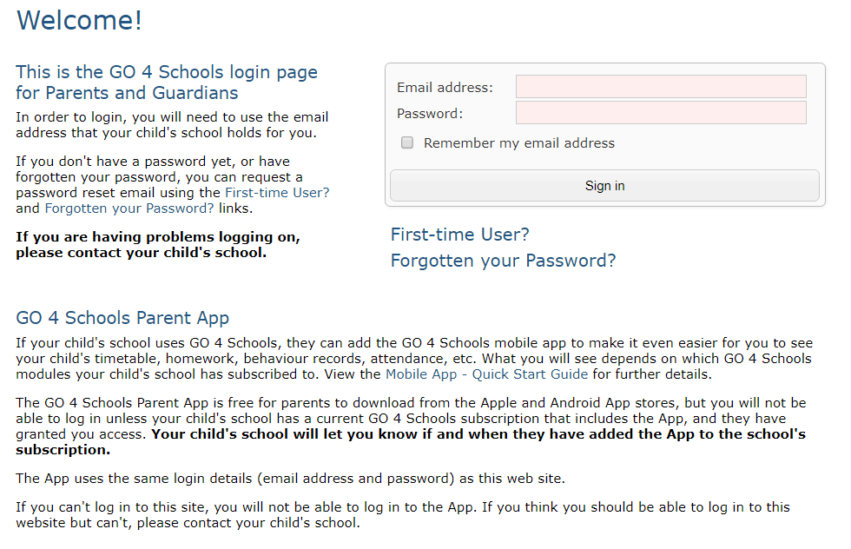
- You will receive an email with a password link, please check your spam/junk or other mailboxes for this.
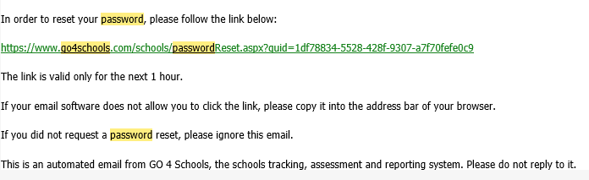

- If you do not receive this link, have recently changed your email address or have any other problems logging in to the system, please contact

lgatward@obhs.co.uk

