GCSE Music
Exam Board: Edexcel | 1 Paper (40%)  2 practical units (30% each)  1 hour 45 mins;  80 Marks

Skills students are examined on:
Appraising Skills
The purpose of this component is to assess students’ listening and appraising skills through the study of music across a variety of styles and genres.
The content is grouped into four areas of study, each of which contains two set works.
Students need to be able to recognise and answer questions on key musical features in the set works.

Useful websites:
https://obhs.musicfirst.co.uk students have individual logins.
www.musictheory.net
search GCSE music 1-9 in YouTube for some excellent resources.

Suggested revision activities to help your child prepare for the English Language exam:
Students need to know the following:
● Form and structure of the music
● Appropriate musical vocabulary for each work
● Stylistic features of the music
● How music relates to the context in which it was created
● How to express and justify their opinions and preferences.
Listen to the set works with your child as often as possible. Use the knowledge organisers to ask the questions about each piece.
Key Terms and Elements of Music
Use the revision aids from Mr Jay to fill in the key features of the set works. Use knowledge organisers to start then try to do them from memory.
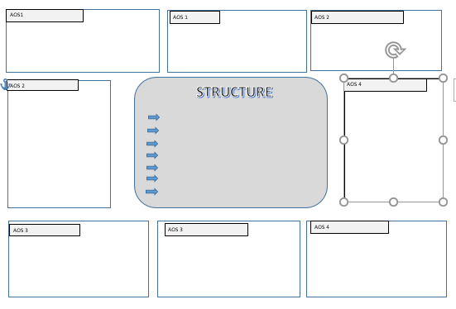

Music Theory
Help your child to gain an understanding of basic music theory. There are resources on Focus on Sound and www.musictheory.net as well as my handouts.

There is an essay question where they have to compare one of the set works with a piece of unfamiliar music from the same genre. They will be able to use skills and techniques from their English lessons, coupled with their knowledge of the key musical terms.
Create a glossary of terms
Encourage your child to go back through their work and create a glossary of all of the terms they have used in Music. I have some available where students write in the definitions.
Term | Definition | Look/ cover/ write/ check practise | Use it in a sentence

Encourage them to use the Focus On Sound website. They have their own login and this has lessons and tests on all of the set works plus wider listening. There are also pages to help with musical dictation.
Encourage your child to listen to the pieces suggested for ‘wider listening’. There will be a question on unfamiliar music linked to the set works by style or time period. Ask them to use the musical key terms to describe the pieces.
Make sure your child knows the key musical terms, what they mean, and how to use them in the context of each piece. If they don’t understand the words being used in the question, they can’t answer it.

