Literature Revision

Title of Text:

__________________________________
- Write the events of the plot along the line in chronological order. | - Draw lines between events that are connected. Which is the cause / effect? Are there multiple causes which lead to an effect? | - Identify the climax / turning point of the plot by drawing a red circle around it. How is this moment important? | - Identify important moments for each character by circling in blue. How is this moment important? | - Identify the concluding moments of the play by highlighting in yellow. What kind of ending do they create? Effect om audience?

Character Profile
What are the personality traits of this character?

How are they treated by other characters?

What happens to this character in the text?
Beginning
Middle
End

Has this character changed by the end? If so, how?

What ideas from the writer’s time does this character link to? How?

What ideas does the writer show through this character? Is there a message for his audience?

How does the audience feel about / respond to this character? Why?

Character Profile
What are the personality traits of this character?

How are they treated by other characters?

What happens to this character in the play?
Beginning
Middle
End

Has this character changed by the end? If so, how?

What ideas from the writer’s time does this character link to? How?

What ideas does the writer show through this character? Is there a message for his audience?

How does the audience feel about / respond to this character? Why?

Character Profile
What are the personality traits of this character?

How are they treated by other characters?

What happens to this character in the text?
Beginning
Middle
End

Has this character changed by the end? If so, how?

What ideas from the writer’s time does this character link to? How?

What ideas does the writer show through this character? Is there a message for his audience?

How does the audience feel about / respond to this character? Why?

Character Profile
What are the personality traits of this character?

How are they treated by other characters?

What happens to this character in the play?
Beginning
Middle
End

Has this character changed by the end? If so, how?

What ideas from the writer’s time does this character link to? How?

What ideas does the writer show through this character? Is there a message for his audience?

How does the audience feel about / respond to this character? Why?

Character Profile
What are the personality traits of this character?

How are they treated by other characters?

What happens to this character in the text?
Beginning
Middle
End

Has this character changed by the end? If so, how?

What ideas from the writer’s time does this character link to? How?

What ideas does the writer show through this character? Is there a message for his audience?

How does the audience feel about / respond to this character? Why?

Character Profile
What are the personality traits of this character?

How are they treated by other characters?

What happens to this character in the play?
Beginning
Middle
End

Has this character changed by the end? If so, how?

What ideas from the writer’s time does this character link to? How?

What ideas does the writer show through this character? Is there a message for his audience?

How does the audience feel about / respond to this character? Why?

Revising key quotes…
Get some card from your teacher and create flash cards. You could use either of the formats below:

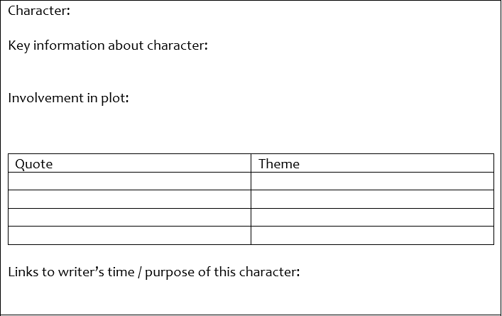

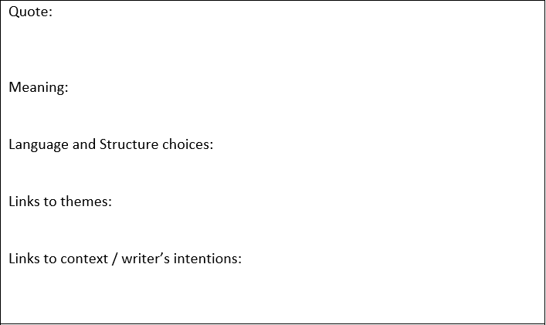

 | Key information | How does this link to the text?  What does it tell us about the writer’s reasons for writing?  What does it help us to understand about the ways characters are presented?
Context and intentions: use your knowledge map to note down Key information about the writer’s time in the left column. Use the questions in the right column to help you make links to the text.
Complete the following quizzes for the text you studied
A Christmas Carol
- In which year was A Christmas Carol published?
- When Dickens was a child, where was his father sent?
- What did Dickens have to do while his father was there?
- What did wealthy Victorians believe about poverty?
- What was the purpose of a Workhouse?
- What was the name of the law which was passed to reduce the cost of helping the poor?
- In which 3 ways is poverty shown in the novel?
    - ___________________________________
    - ___________________________________
    - ___________________________________
- How were children punished in Workhouses?
- Why did Dickens write the novel?
- Which Christmas did Dickens write his novel for?
- Name 3 Christmas tradition started by the Victorians:
    - ___________________________________
    - ___________________________________
    - ___________________________________

A Christmas Carol
Characters:
- Which of the spirits does not speak to Scrooge?
- What is Jacob Marley forced to drag about as a result of his sinful life?
- Why does Scrooge like Darkness?
- Which character is Fred’s mother?
- Why does Belle end her engagement with Scrooge?
- What is the Ghost of Christmas Present's throne made of?
- To whom does Scrooge send the Christmas turkey?
- Which one of the spirits has a glowing head?
- Which spirit takes Scrooge to a ship at sea?
- What is Scrooge's typical response to "Merry Christmas"?
Plot:
- How many years ago did Marley die?
- What is the first appearance of Marley’s Ghost?
- When does Marley’s Ghost say the first spirit will come?
- How many nights is Scrooge visited on?
- Whose home does the Ghost of Christmas Present take Scrooge to?
- Which children does the Ghost of Christmas Present show to Scrooge before he leaves?
- What does the Ghost of Christmas to come represent?
- In the final visit, Scrooge is shown his own what?
- What mood does Scrooge wake up in on Christmas day?
- Where does he go?

Jekyll and Hyde
- In which year was Jekyll and Hyde published?
- Which famous historic figure is often linked to Hyde? Why?
- The new developments in science conflicted with which major part of Victorian life? Why?
- Which Victorian Scientists are linked to the novel? How?
- What is ‘duality’ and which parts of the human mind does it refer to?
- Who is responsible for developing this theory?
- How is duality shown in the novel?
- What was the Industrial Revolution?
- List some of the features of the Gothic genre that are used in the novel
- Which words beginning with ‘R’ were Victorians most concerned with?
    - ____________________________________
    - ____________________________________
    - ____________________________________

Jekyll and Hyde
Characters:
- Through which character is most of the story told through?
- Who tell this character the story of the man trampling the child?
- Who is described as ‘pale and ‘dwarfish’?
- Which is described as ‘large, well-made’?
- Which character does the reader meet first: Jekyll or Hyde?
- What does this tell you about the level of power / control of each character?
- What is the name of Jekyll’s man-servant?
- How is Hyde characterised for much of the novel?
- Which characters are harmed / murdered by Hyde?
- Which character provides the account of Hyde changing into Jekyll?
Plot:
- What setting is described in the opening of the novel?
- What times of day do Hyde’s attacks take place? What is significant about this?
- What happens to the weather after the murder of Carrew?
- Which two documents alert Utterson to the connection between Jekyll and Hyde?
- What does Utterson notice about the signatures of Jekyll and Hyde?
- In what setting does the reader meet Jekyll for the first time? What is significant about this?
- What is the importance of the ‘red baize door’?
- What signs are given to show that Hyde’s power is increasing, and Jekyll’s is decreasing?
- Where is Hyde’s body found?
- Whose account conclude the novel?

