GCSE English Knowledge Maps
The main part of your homework (your teachers may set you additional homework to supplement work on the Language Exams) for the rest of your GCSE English course will centre around developing your knowledge of the content of the four Literature elements you will be examined in:
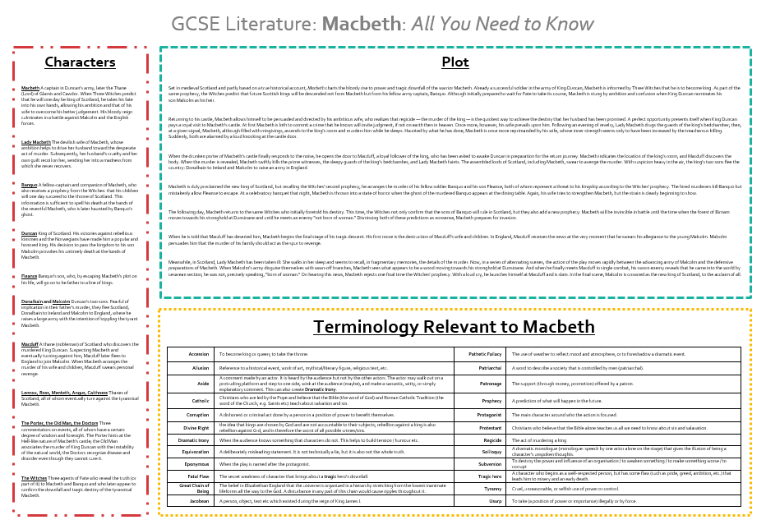
(A Christmas Carol or Jekyll and Hyde, An Inspector Calls, Macbeth and Relationships or Conflict Poetry).
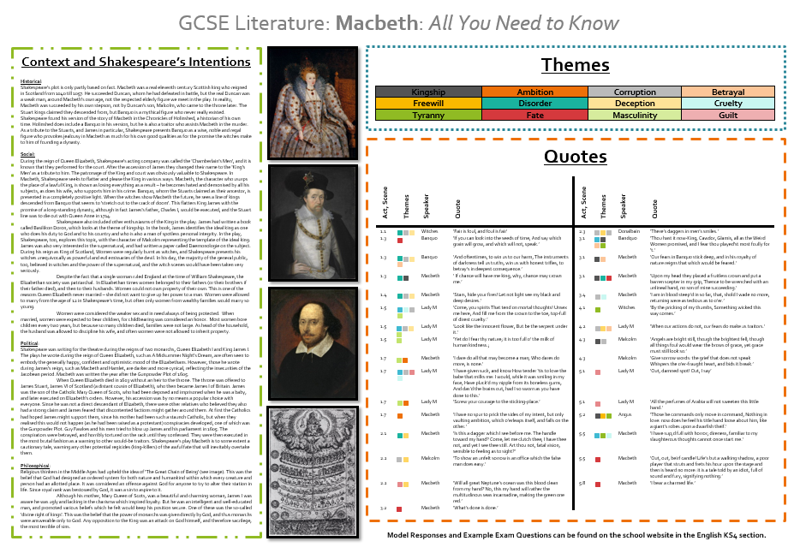
As you can see from the example on the left, there is a lot of information for you to make sure you know. The information is usually split into 6 main sections:
- Characters: this gives an overview of their personality and main involvement in the plot
- Plot: this summarizes the plot
- Terminology: this gives a list of terms and definitions you will need to discuss the text
- Context and Intentions: this tell you about the time period the text was produced in and the writer’s reasons for producing the text
- Themes: a list of the major ideas of the text
- Quotes: a list of some quotes you should make sure you know, although there are many more that your teacher will highlight to you too.
Your teachers will expect to see evidence of your revision of this key information, and will arrange deadlines for you to present your work to them. We have designed a range of compulsory tasks for you to complete to enable you to engage with the knowledge maps. These materials can be found in the English section on SharePoint, or on the School Website and include activities such as:
- Plot timelines and structure exploration
- Character profiles
- Flashcards
- Quizzes
- Context application
If you have trouble printing these resources, please speak to your English teacher.
You will have a term to complete all activities for each knowledge map.

