German GCSE
Exam Board: AQA | 4 Papers (25% each)  Listening Reading  Speaking Writing | https://www.aqa.org.uk/exams-administration/exams-guidance/find-past-papers-and-mark-schemes

Skills students are examined on:
Reading and listening skills | Writing Skills
Reading/listening to German passages on a wide variety of topics including some new language.  Answering in German  Answering in English  Multiple choice  True/false/not mentioned  Positive/ negative/ both  Identify the true statements  Translating in to English | A short essay of 90 words covering all 4 bullet points  A longer essay of 150 words which requires planning.  A translation in to German – application of grammar rules essential especially recognising and using tenses.
 | Speaking Skills
Rôle play
Describe a photo and answer general topic questions

Suggested revision activities to help your child prepare for the GCSE exam:
Get the whole family to learn 5 new words a day, quiz each other. Play Kahoot as a family to make it a competition.
https://kahoot.it/

Knowing vocabulary is essential
Learn 5 new words a day!
Remind yourself of the words you know.
Download Quizlet or Memrise on to a phone or tablet and practise GCSE Core vocabulary on the go, in the car, in front of the tv, on the bus etc.
www.Quizlet.com and www.Memrise.com
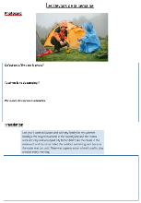
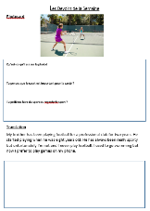
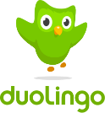
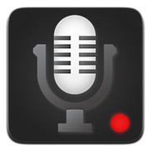
Planning an Essay
Help them to organise their ideas and plan a response. Encourage them to do the following:
- Read the question and highlight the key words;
- Draw a spider diagram to plan the content;
- Note down key phrases in German for each content section.
- Have they used at least three tenses?
- Have they used opinions?

Translating in to German
Read out the English translation from your child’s ‘Homework of the week’ sheets and they write the German.
Complete two listening and reading questions every two days from the revision work book – the answers are in the back!
Record questions and answers to listen to. Do you know a great German speaker who could do this?

Practise role plays, photocards and conversation questions.
These are all essential for the
speaking and writing exams.
Ask them to reply in German.
Ask them to ask you a question in German
Ask your child what it means in English
Does their answer include an opinion?
What tense should they use? Present, past or future?
Ask a question in German
Practise Speaking
Your child has a speaking folder with model and worked answers to speaking questions

