PE GCSE
Exam Board: Edexcel
Component 1: written paper | Fitness and Body systems | 1 hour and 45 minutes | 90 marks (36% of qualification)
Component 2: written paper | Health and Performance | 1 hour and 15 minutes | 70 marks (24% of qualification)
Component 3: Practical Performance | 3 sports, One team  One individual, One free choice | 1 day moderation | 105 marks (30% of qualification)
Component 4: Written coursework | Personal Exercise Programme |  | 20 marks (10% of qualification)

Suggested revision activities to help your child prepare for the PE exam:
Mind-Mapping
This is a great way of testing what you already know and organising your notes effectively. You might start by only using what you can remember, and then use your exercise book and any other resources to add to your notes.
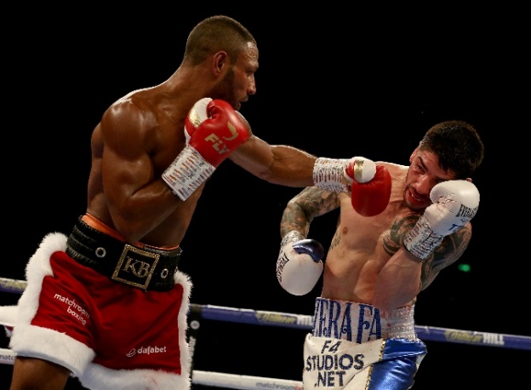
Encourage your student to organise their revision notes in order to help them to remember all of the important information. They could try using a table (see below).
I have started one on body systems for them…
Body System | Functions | Definitions | Short effects of Exercise | Long term effects of Exercise | Diet | Drugs | Other
Skeletal | - Muscle attachment.  - Production of blood cells.  - Protection of vital organs.  - Mineral storage. | Ligaments = joins bone to bone. | There are none | Weight bearing exercise = increases bone density | Calcium | None | Joints.  Bone classification

Create a glossary of terms
Encourage your child to go back through their exercise book and create a glossary of all of the key terms. They then need to link them to a sporting example
Term | Definition | Look/ cover/ write/ check practise | Link to a sporting example

To train for power the boxer could do weight training – high weight/low reps.

Power – The boxer needs power to be able to punch hard to knock the opponent out.
The fitness test for power is – standing board jump.

What else could you add?

Power = Strength x Speed, completing strength activities quickly.

