Bakery

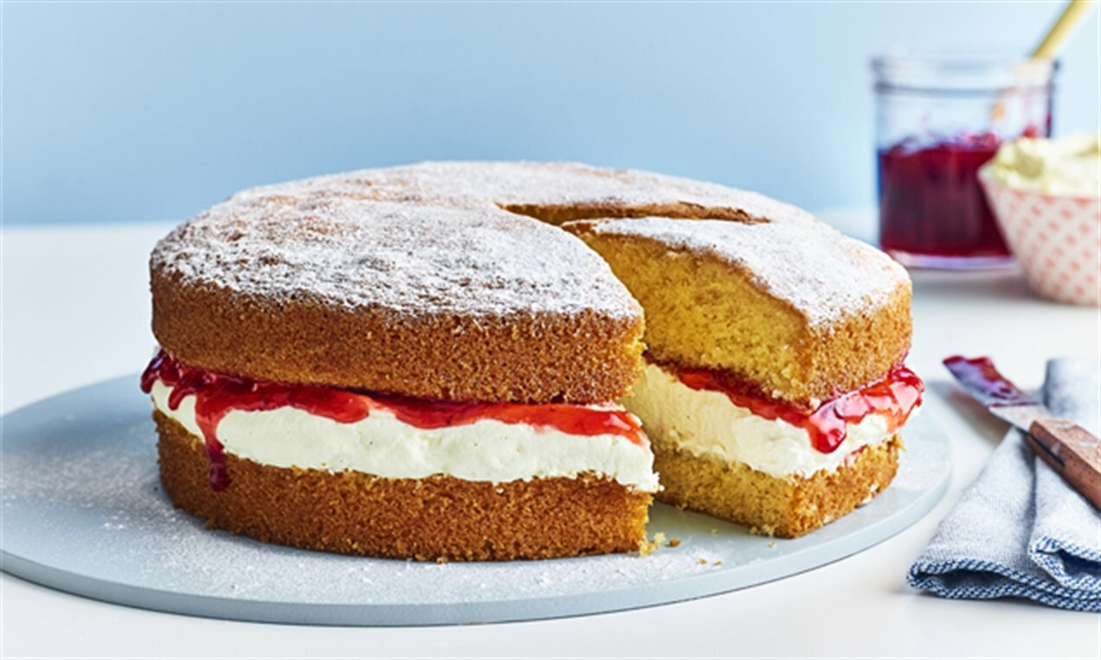
You are now all BAKERS!

You need to bake 12 Victoria sponges for a client.

- What will you need to buy? How much?
- How much will it be per cake? For 12 cakes?
- What will you charge for your time / labour?
- Will you allow some money for profit?

In total – What will you charge your client for the 12 cakes?

Give children a Victoria sponge recipe:
Classic Victoria sandwich recipe | BBC Good Food

Use laptops / iPad to look up the prices of ingredients:
Sainsbury's online Grocery Shopping and Fresh Food Delivery (sainsburys.co.uk)
Asda.com - Online Food Shopping, George, & more
Tesco Groceries - Online food shopping - Grocery delivery - Tesco Groceries
Online Food Shopping | Iceland Groceries

Possible questions to consider:
- Do you need to get all ingredients from one shop?
- Is there a delivery charge or would you go to collect it?
- Would you buy jam to go inside or make it? – find a recipe and cost it up to compare.

