CORE QUESTIONS
Economic World
Section B

OBHS Core Questions:
Subject: Geography
Year and Term: GCSE Autumn Year 10
Topic: Section B: Economic World-Overview, Jamaica and Nigeria
Learn these questions to build a strong foundation of knowledge for this half-term. Ask family or friends to test you regularly, or practise on your own using the ‘Look, Say, Cover, Write’ method.
1 | What is development? | Development is the process of improvement in people's quality of life, including economic, social, and political progress.
2 | How can development be measured? | Development can be measured using indicators such as:  - Gross National Income (GNI) per capita  - Human Development Index (HDI)  - Life expectancy  - Literacy rate  - Infant mortality  - HDI
3 | What are the limitations of economic and social measures to classify development? | - Data could be out of date or hard to collect  - Data may be unreliable  - They focus only on certain aspects of development e.g. GDP rather than corruption levels or human rights  - Government corruption may mean that data is unreliable
4 | What does HDI cover? | - Life expectancy at birth  - Mean years of schooling for adults aged 25  - Expected years of schooling for children of school entering age.  - Gross national income per capita (GNI)/PPP
5 | What are the benefits of using HDI over other measures? | It covers more than one factor, looking at both social and economic factors.
6 | What is the development gap? | The development gap is the difference in levels of development between the richest and poorest countries (HICs and LICs).
7 | What factors affect development? | Physical: Climate, natural disasters, landlocked location  Economic: Trade, debt, reliance on primary products  Historical: Colonialism, conflict  Social and political: Corruption, stability, access to education and healthcare
8 | How can the development gap be reduced? | Investment  Industrial development  Aid (e.g. UK aid to LICs)  Fair trade  Debt relief  Tourism
9 | What is the demographic transition model? | The Demographic Transition Model (DTM) is a theoretical model that describes how a country's population changes over time as it develops economically. It outlines the relationship between birth rates, death rates, and overall population growth through five stages  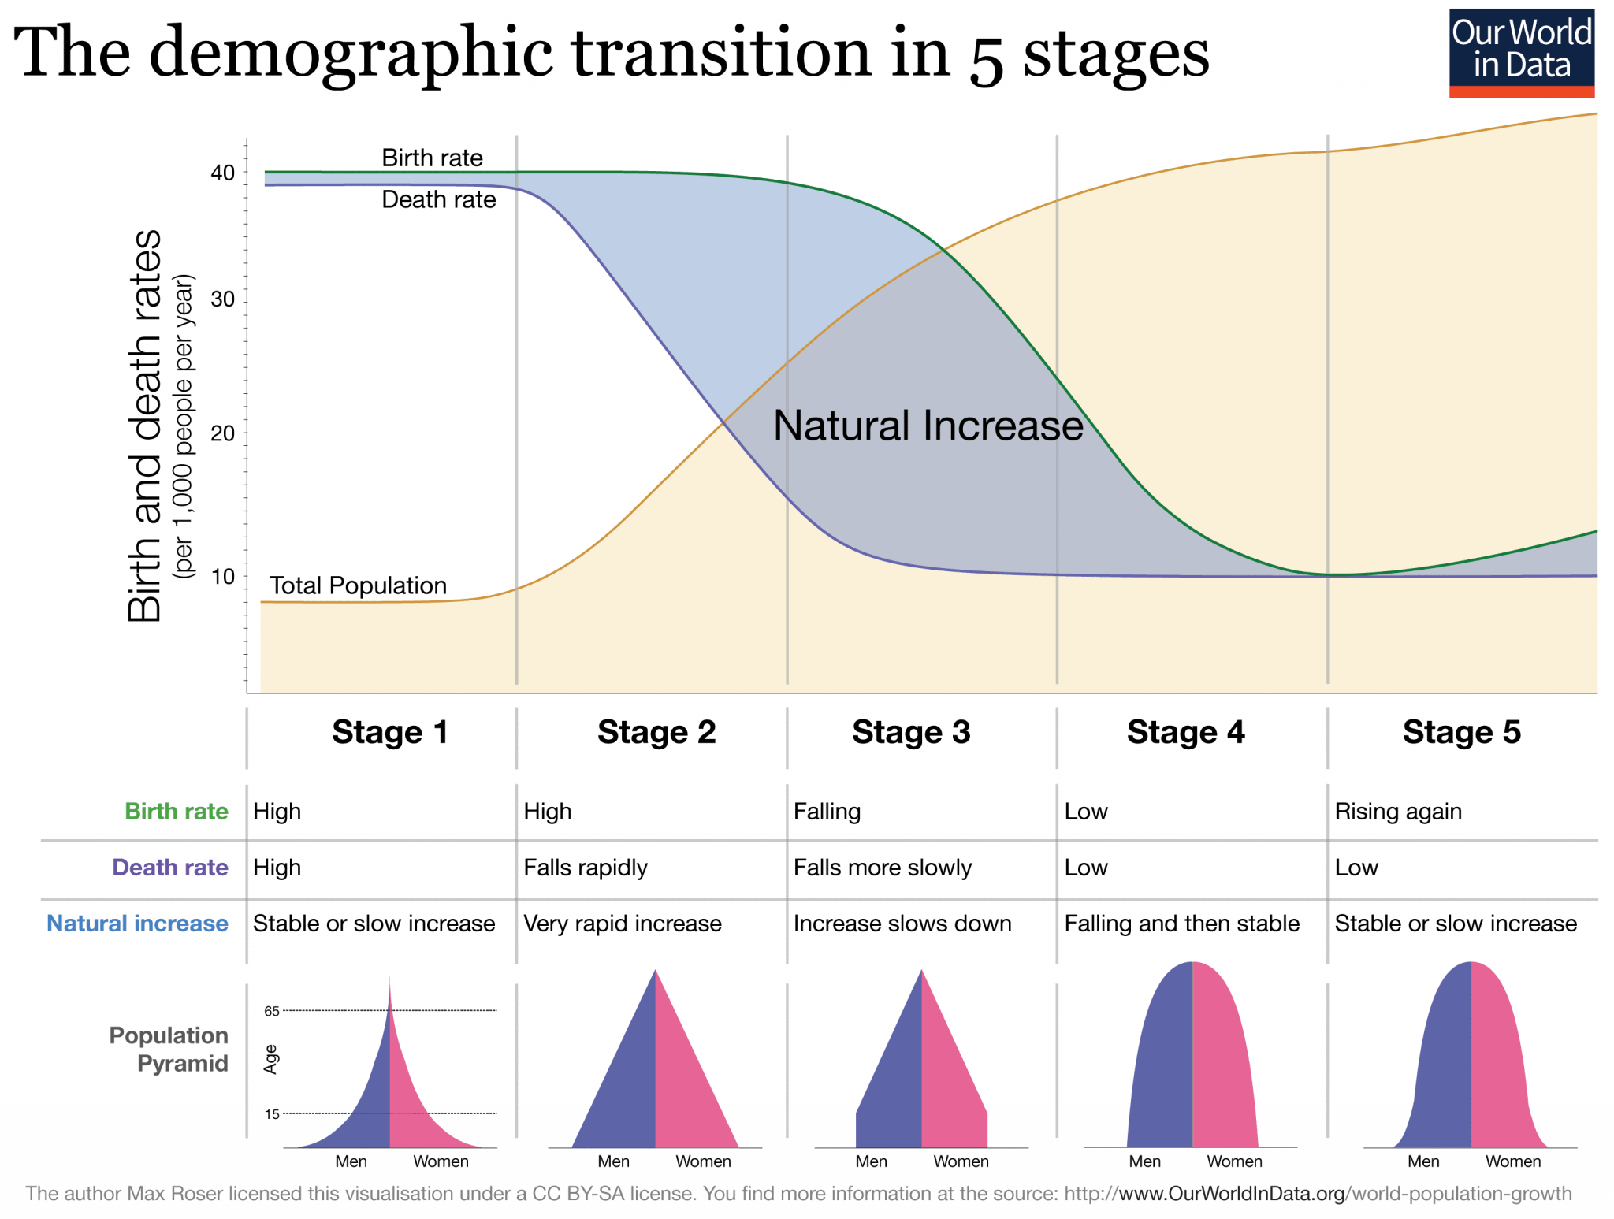
  Stage | Birth Rate | Death Rate | Population Growth | Example
  1 | High | High | Slow/stable | Pre-industrial tribes
  2 | High | Falling | Rapid | Chad, Niger
  3 | Falling | Low | Slowing | India, Brazil
  4 | Low | Low | Stable/slow | UK, USA
  5 | Very low | Low/slight | Decline possible | Japan, Germany
CASE STUDY JAMAICA
10 | How has tourism helped reduce the development gap in Jamaica | Tourism is Jamaica's largest source of income.  It contributes over 20% of GDP.  Infrastructure (roads, airports) has improved.
11 | How many jobs has it created? | Created 200,000+ jobs.
12 | How much was tourism worth to the economy? | $2 billion a year
13 | What are the main contributors to the economy of Jamaica? | Minerals-bauxite and oil  Agricultural product-sugar, rum  Some manufacturing  Tourism
CASE STUDY NIGERIA
14 | Case Study: How has a TNC helped Nigeria develop? | Shell operates in the Niger Delta:  - Provides jobs and training for Nigerians.  - Brings investment and helps develop infrastructure.  - Criticism: oil spills, environmental damage, and limited profits staying in Nigeria
15 | What is a TNC? | A Transnational Corporation (TNC) is a company that operates in more than one country (e.g. Shell, Nike)
16 | What are the main contributors to the economy of Jamaica? | Minerals-bauxite and oil  Agricultural product-sugar, rum  Some manufacturing  Tourism
17 | How is economic development improving the quality of life for Nigeria’s population? | Reliable and better paid jobs in manufacturing  Better access to safe water  Better diet  Higher disposable income
18 | What are the negatives of TNCs for Nigeria? | Local workers are sometimes poorly paid  Much of the profit generated goes abroad  Working conditions are sometimes very poor.
19 | When was the Bodo Oil spill? | 2008-2009
20 | How much compensation did Shell agree to pay? | £55m
21 | What TNCs operate in Nigeria? | Shell, Unilever (food and drink company), Nestle, VW
22 | What aid does Nigeria get? | It has received a total of $5bn from lots of sources including Action Aid to create the Aduwan healthcare centre, Nets for Life to help with malaria
23 | How many does Shell employ? | 65,000
24 | What is the global importance of Nigeria? Give 3 | Nigeria is an NEE and had the world’s highest average GDP growth for 2010-15  It supplies 2.7% of the world oil  It ranks as the 5th largest contributor to UN peacekeeping missions.
25 | What is Nigeria like socially? | Multi-ethnic, multi faith country  The social diversity is one of its strengths but has also led to conflict
OBHS Core Questions:
Subject: Geography
Year and Term: GCSE Autumn Year 10
Topic: Paper 2 Section B: Economic World-UK Change
1 | How much did they project HS2 would cost | £36 bn
2 | How much did they spend before they cancelled it? | The final cost is still uncertain, but some suggest it was £106bn-130bn
3 | How has fishing changed in the Outer Hebrides? | In 1948 there were over 900 fishing boats registered, now there are only a few
4 | How much has the population declined since 1901 in the Outer Hebrides? | 50%
5 | What are four of the UKs economic and political links? | Television is one of the UKs most successful media exports  The UK has global links through trade, culture, transport and electronic communications.  It is an influential member of the G8, NATO and the UN Security Council  The UKs most important trading links are with the EU-as a single market goods can be traded between member states without tariffs (for now)
6 | Where is the Torr Quarry? | Mendip Hills, Somerset  How many does it employ?  Employs over 100 people  What does it extract?  Extracts limestone
7 | How have they made it better for the environment? | Restored to provide wildlife lakes
8 | How does the Torr quarry aim to be more sustainable? Give 3 | 200 acres landscaped to blend into the countryside  Regular monitoring of noise, vibration, airborne emissions and water quality  Rail transport of goods reduces road usage
9 | What are some strategies are used to resolve regional differences? Give 3 | HS2  South-west superhighway  Liverpool 2
10 | What area do you study for population growth? | South Cambridgeshire
11 | What are the social effects of rural change in areas where there are growing numbers? Give 2 | Commuters continue to use services in places they work –e.g. shops so rural services decline  Increased traffic  What are the economic effects of rural change? Give 1 positive and 1 negative  -Reduction of agricultural land as it is sold for housing  + Increase in construction jobs
12 | How is South Cambridge changing? | Some areas are growing e.g. rural Cambridge due to excellent transport links and people wishing to commute
13 | What area do you study for population decline? | Outer Hebrides
14 | How is the Outer Hebrides changing? | Remote areas like the Outer Hebrides are experiencing decline due to lack of employment and infrastructure.
15 | What is de-industrialisation? | The decline of a country's traditional manufacturing industry due to exhaustion of raw materials, loss of markets and overseas competition.
16 | What is globalisation? | A process creating a more connected world, with increases in the global movements of goods (trade) and people (migration & tourism)
17 | What is a science park? | A collection of scientific and technical knowledge-based businesses located on a single site
18 | What is the North–South divide? | Economic and cultural differences between southern England and the rest of the UK
19 | What is post-industrial economy? | The shift of some HIC economies from producing goods to providing services
20 | What is the quaternary sector? | Employment sector that includes jobs in hi-tech industries, research, information technology and the media
21 | How has UK industry changed over time? | Before 1800, most people worked in primary industries such as farming.  The industrial revolution in the C19th led to more involved in secondary industries  In the last few decades it changed again with a big shift towards the tertiary sector.
22 | Why has it changed? | Machines and technologies have replaced people  De-industrialisation  Cheaper goods elsewhere  Lack of investment  Better quality of life in less physically demanding/dangerous work.
23 | What were the impacts of industry on the physical environment? | Large scale extraction such as mining can have huge impacts as quarries were cut into the landscapes and huge waste tips piled up on the edges of mining settlements  Manufacturing plants can look ugly  Industrial processes can be polluting to the air, water and soil  Waste products from manufacturing can be harmful  Increased transportation of goods leads to pollution
24 | How can a modern industrial development be more environmentally sustainable? | Technology can be used to remove harmful emissions  Desulphurization can remove harmful gases from power station chimneys  Stricter environmental targets put in place for industry  Heavy fines imposed when industrial pollution occurs

OBHS Core Questions:
Subject: Geography
Year and Term: GCSE Autumn Year 10
Topic: Paper 2 Section B: Economic World-UK Change
Learn these questions to build a strong foundation of knowledge for this half-term. Ask family or friends to test you regularly, or practise on your own using the ‘Look, Say, Cover, Write’ method.
1 | How much did they project HS2 would cost | £36 bn
2 | How much did they spend before they cancelled it? | The final cost is still uncertain, but some suggest it was £106bn-130bn
3 | How has fishing changed in the Outer Hebrides? | In 1948 there were over 900 fishing boats registered, now there are only a few
4 | How much has the population declined since 1901 in the Outer Hebrides? | 50%
5 | What are four of the UKs economic and political links? | Television is one of the UKs most successful media exports  The UK has global links through trade, culture, transport and electronic communications.  It is an influential member of the G8, NATO and the UN Security Council  The UKs most important trading links are with the EU-as a single market goods can be traded between member states without tariffs (for now)
6 | Where is the Torr Quarry? | Mendip Hills, Somerset  How many does it employ?  Employs over 100 people  What does it extract?  Extracts limestone
7 | How have they made it better for the environment? | Restored to provide wildlife lakes
8 | How does the Torr quarry aim to be more sustainable? Give 3 | 200 acres landscaped to blend into the countryside  Regular monitoring of noise, vibration, airborne emissions and water quality  Rail transport of goods reduces road usage
9 | What are some strategies are used to resolve regional differences? Give 3 | HS2  South-west superhighway  Liverpool 2
10 | What area do you study for population growth? | South Cambridgeshire
11 | What are the social effects of rural change in areas where there are growing numbers? Give 2 | Commuters continue to use services in places they work –e.g. shops so rural services decline  Increased traffic  What are the economic effects of rural change? Give 1 positive and 1 negative  -Reduction of agricultural land as it is sold for housing  + Increase in construction jobs
12 | How is South Cambridge changing? | Some areas are growing e.g. rural Cambridge due to excellent transport links and people wishing to commute
13 | What area do you study for population decline? | Outer Hebrides
14 | How is the Outer Hebrides changing? | Remote areas like the Outer Hebrides are experiencing decline due to lack of employment and infrastructure.
15 | What is de-industrialisation? | The decline of a country's traditional manufacturing industry due to exhaustion of raw materials, loss of markets and overseas competition.
16 | What is globalisation? | A process creating a more connected world, with increases in the global movements of goods (trade) and people (migration & tourism)
17 | What is a science park? | A collection of scientific and technical knowledge-based businesses located on a single site
18 | What is the North–South divide? | Economic and cultural differences between southern England and the rest of the UK
19 | What is post-industrial economy? | The shift of some HIC economies from producing goods to providing services
20 | What is the quaternary sector? | Employment sector that includes jobs in hi-tech industries, research, information technology and the media
21 | How has UK industry changed over time? | Before 1800, most people worked in primary industries such as farming.  The industrial revolution in the C19th led to more involved in secondary industries  In the last few decades it changed again with a big shift towards the tertiary sector.
22 | Why has it changed? | Machines and technologies have replaced people  De-industrialisation  Cheaper goods elsewhere  Lack of investment  Better quality of life in less physically demanding/dangerous work.
23 | What were the impacts of industry on the physical environment? | Large scale extraction such as mining can have huge impacts as quarries were cut into the landscapes and huge waste tips piled up on the edges of mining settlements  Manufacturing plants can look ugly  Industrial processes can be polluting to the air, water and soil  Waste products from manufacturing can be harmful  Increased transportation of goods leads to pollution
24 | How can a modern industrial development be more environmentally sustainable? | Technology can be used to remove harmful emissions  Desulphurization can remove harmful gases from power station chimneys  Stricter environmental targets put in place for industry  Heavy fines imposed when industrial pollution occurs

