 | Question | Answer
1. | 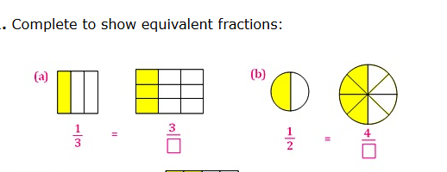 | - 9  - 8
2. | 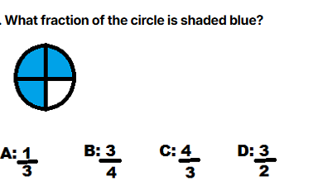 | B
3. | Simplify the fraction $\frac{12}{18}$ | $$\frac{2}{3}$$
4. | $$\frac{1}{5}+\frac{3}{5}$$ | $$\frac{4}{5}$$
5. | Write the complement of $\frac{3}{20}$ | $$\frac{17}{20}$$
6. | Find $\frac{5}{6}$ of 36 | 30
7. | Write $\frac{23}{5}$as a mixed number | $$4\frac{3}{5}$$
8. | Write the reciprocal of $\frac{4}{7}$ | $$\frac{7}{4}$$
9. | $$\frac{3}{4}×\frac{5}{7}$$ | $$\frac{15}{28}$$
10. | Find the number that is halfway between $\frac{2}{5}$ and $\frac{7}{8}$ | $\frac{16}{40}$and $\frac{35}{40}$  $\frac{51}{40}$ halved $\frac{25.5}{40}=\frac{51}{80}$
11 | Which fraction is larger: $\frac{5}{12}$ or $\frac{4}{9}$? | $\frac{5}{12}=\frac{15}{36}$ < $\frac{4}{9}= \frac{16}{36}$
12 | Find the reciprocal of $\frac{11}{9}$ | $$\frac{9}{11}$$
13 | Divide $\frac{5}{6}$ ÷ $\frac{2}{3}$ | $$\frac{15}{12}=\frac{5}{4}$$
14 | 2$\frac{1}{3} ×1\frac{1}{2}$ | $$\frac{7}{2} or 3\frac{1}{2}$$
15 | 1$\frac{2}{3}$ + 2$\frac{1}{4}$ | $$\frac{47}{12} or 3\frac{11}{12}$$
16 | 3$\frac{1}{2}-1\frac{3}{4}$ | $$\frac{7}{4} or 1\frac{3}{4}$$
17 | 3$\frac{1}{3}$ ÷ 1$\frac{2}{5}$ | $\frac{50}{21}$or 2$\frac{8}{21}$
18 | $${(\frac{3}{4})}^{2}$$ | $$\frac{9}{16}$$
19 | $$\sqrt{\frac{64}{81}}$$ | $$\frac{8}{29}$$
20 | 6 is of 18 | $$\frac{1}{3}$$
OBHS Core Questions:
Subject: Maths
Year and Term: Spring 2 yr 7
Topic: NP7
Learn these questions to build a strong foundation of knowledge for this half-term. Ask family or friends to test you regularly, or practise on your own using the ‘Look, Say, Cover, Write’ method.

