 | Question | Answer
1. | If 1 apple costs 22p how much do 3 apples  cost? | 66 p
2. | To make 5 cookies, Sarah uses 100g of sugar.  How much butter would she need for 10  Cookies? | 200 g
3. | Complete the missing table of values so that they are directly proportional  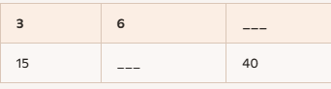 | 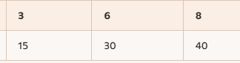
4. | Complete the missing table of values so they are inversely proportional  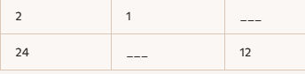 | 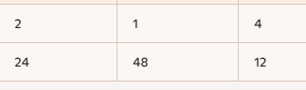
5. | A shop sells packs of colouring pens in two different sizes:  - Pack A: 12 pens for £3.60  - Pack B: 20 pens for £5.80  Which pack is the best value for money? | Pack A  - Cost per pen = $\frac{3.60}{12}=£0.30$per pen  Pack B  - Cost per pen = $\frac{5.80}{20}=£0.29$per pen  Conclusion Pack B cheaper
6. | Write 28% as a decimal | 0.28
7. | To increase by 28% what would you multiply by? | 1.28
8. | To decrease by 28% what would you multiply by? | 0.72
9. | if the exchange rate is £1 = €1.15, how many euros would you receive for £50? | 57.50
10. | A rectangle with dimensions of 3 cm by 4 cm is increased by a scale factor of 3. What are the lengths of the new sides? | 9 cm and 12 cm
11 | It takes 5 days for 3 builders to build a wall. How long would it have taken 2 builders? | 5 x 3 = 15  15 ÷ 2 = 7.5 days
12 | A person drive to work takes 40 minutes while doing an average speed of 60 mph. If this speed is reduced to 30 mph how long would it take them? | Because speed is halved, the journey time will be doubled.  Answer = 80 minutes or 1 hour 20 minutes
13 | What is 12% of 200? | 10% = 20, 2% = 4, therefore 12% = 24
14 | Decrease 350 by 15% | 0.15 x 350 = 52.5. 350 – 52.5 = 297.5
15 | If £60 becomes £75, what percentage change is this? | 25% increase
18 | If £80 decreases to £60, what percentage change is this? | 25% decrease

OBHS Core Questions:
Subject: Maths
Year and Term: Autumn 2 year 8
Topic: NP10
Learn these questions to build a strong foundation of knowledge for this half-term. Ask family or friends to test you regularly, or practise on your own using the ‘Look, Say, Cover, Write’ method.

