 | Question | Answer
1. | What is a regular polygon? | All sides and angles are equal (e.g., equilateral triangle, square, regular hexagon).
2. | What is the sum of the angles in a Triangle? | 180 degrees
3. | What is the sum of the angles in a Quadrilateral? | 360 degrees
4. | For an n-sided polygon, the sum of interior angles is? | (n-2) x 180
5. | A pentagon (5 sides) has an interior angle sum of? | (5-2) * 180 = 540 degrees.
6. | What is the Exterior Angle Sum? | The sum of exterior angles of any polygon (regular or irregular) is always 360 degrees.
7. | Each exterior angle of a regular polygon is 24°. How many sides does the polygon have? | 15
8. | What the shape properties of a Rhombus? | Shape with 4 equal sides. 2 pairs of parallel sides and 2 pairs of equal angles
9. | Draw an example of the following angles with correct notation:  - Alternate  - Corresponding  - Co-interior | 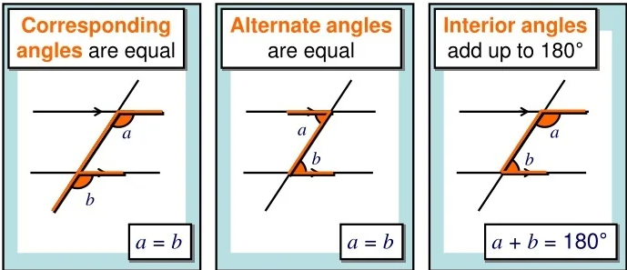
10. | In a parallelogram, if one angle is 70 degrees, what are the other angles? | 70 degrees, 110 degrees, 110 degrees
11 | Vertically opposite angles are always said to be what? | Equal
12 | Bearings should always be read from which direction? | Clockwise
13 | Bearings should always be how many digits? | 3
14 | What is the bearing direction for East? | 090
15 | Each exterior angle of a regular decagon is? | 360 ÷ 10 = 36 degrees
16 | What is the name of the 4 sided shape with 1 pair of parallel lines? | Trapezium
17 | An isosceles triangle has an angle of 50⁰. What are the other angles? (2 answers) | - 50 and 80 degrees or  - 65 and 65 degrees
18 | Find the missing angle in a triangle: 35° and 85° | 60 degrees
19 | Find the missing co-interior angle if one is 70° | 110 degrees
20 | What is the name of a 12-sided polygon? | A dodecagon
OBHS Core Questions:
Subject: Maths
Year and Term: Spring 1 yr 8
Topic: GM2
Learn these questions to build a strong foundation of knowledge for this half-term. Ask family or friends to test you regularly, or practise on your own using the ‘Look, Say, Cover, Write’ method.

