 | Question | Answer
1. | Find the missing terms in the linear sequence. 67, 69, _______, 73, 75, _________ | 71 and 77
2. | The term-to-term rule for a linear sequence is Start at 5. Add 3 each time. Write the first five terms in the sequence. | 5, 8, 11, 14, 17
3. | What is a geometric sequence? | A geometric sequence is a sequence where each term is found by multiplying the previous term by a constant value.
4. | 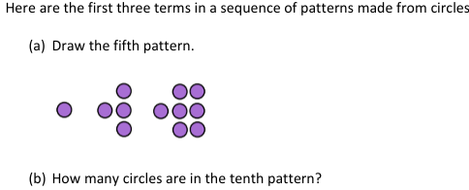 | 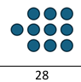
5. | Name these sequences:  1, 4, 9, 16, 25, 36, 49, …  1, 3, 6, 10, 15, 21, … | Square numbers  Triangular numbers
6. | Here is a linear sequence.  20, 18, 16, 14, 12, ………  Fill in the gaps to write its term-to-term rule.  Start at ______________.  _________________________ each time. | Start at 20  Take away 2 each time
7. | What is the nth term of the following sequence:  3, 5, 7, 9... | Constant difference = +2  “0” term (one before) = 1  Therefore = 2n + 1
8. | What is the nth term of the following sequence:  17, 13, 9, 5... | Constant difference = -4  “0” term (one before) = 21  Therefore = -4n + 21, or 21- 4n
9. | 3n + 4 what is the 10th term of this sequence? | (3x10)+4=34
10. | 245 is a term in the linear sequence  $$11n-8$$  Which term is it? | 11n – 8 = 245 (add 8)  11n = 253 ( divide by 11)  N = 23  23rd term
OBHS Core Questions:
Subject: Maths
Year and Term: Summer 2 yr 8
Topic: A7
Learn these questions to build a strong foundation of knowledge for this half-term. Ask family or friends to test you regularly, or practise on your own using the ‘Look, Say, Cover, Write’ method.

