 | Question | Answer
1. | What is a coordinate? | An ordered pair (x, y) that represents a point's location on the grid.
2. | What are the coordinates of each point?  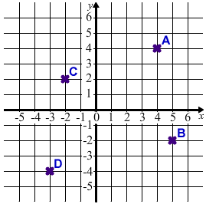 | A = (4,4)  B = (5,-2)  C = (-2,2)  D = (-3,-4)
3. | What is the origin? | The origin is the point (0, 0) where the x and y axes intersect.
4. | What is equation of these lines?  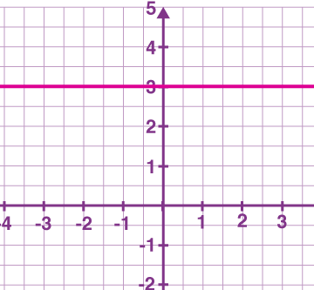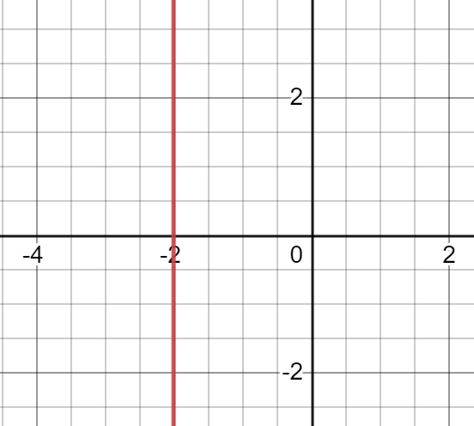 | - Y=3 because it crosses the y-axis at 3  - X=-2 because it crosses the x-axis at -2
5. | Name this graph  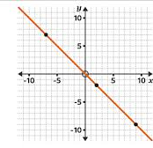 | Y=x
6. | What is the c and m in y=mx+c? | Y-intercept (c):  The point where the line crosses the y-axis.  Gradient (m):  "change in y / change in x"
7. | What is the equation of this line?  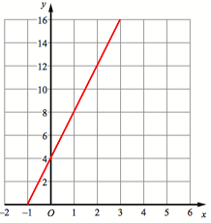 | Y = 2x + 4
8. | What is the midpoint of the line joining the points (2 , 10) and (10 , 40)? | 2 + 10 = 12 10 + 40 = 50  12/2 = 6 50/2 = 25  So… (6,25)
9. | y = 2x + 1 what is the gradient and y intercept of this line? | the gradient is 2. the y-intercept is 1.
OBHS Core Questions:
Subject: Maths
Year and Term: Summer 1 yr 8
Topic: A6
Learn these questions to build a strong foundation of knowledge for this half-term. Ask family or friends to test you regularly, or practise on your own using the ‘Look, Say, Cover, Write’ method.

