 | Question | Answer
1. | What does Expand mean? | Multiplying out of a bracket
2. | What does Factorise mean? | Inverse of expand. Divide by common factors and put back into brackets
3. | Multiply out the bracket (known as “expand”) 3(x + 5) | 3x + 15
4. | Expand the following 7(2x + 8) | 14x + 56
5. | Expand the following 3x(3x – 5) | 9x ²- 15x
6. | 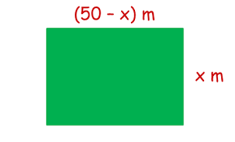  Find the area in terms of x | X(50 – x)  50x - x ²
7. | Expand and simplify. 2(𝑥 − 6) + 5(𝑥 + 5) | =2x – 12 + 5x + 25  = 7x + 13
8. | Expand and simplify. 3(𝑥 − 6) - 7(𝑥 - 2) | = 3x – 18 – 7x + 14  = -4x - 4
9. | Simplify.  20𝑥 + 10  5 | 4x + 2
10. | Multiply out the bracket ¼ (40x+16) | 10x + 4
11. | 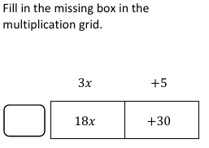 | 6
12. | Factorise the expression fully. 30𝑦 + 6p | 6(5y + p)
13. | Factorise the expression fully x - x ² | x(1 - x)
14. | Expand and simplify the expression. (𝑥 + 3)(𝑥 + 7) | $$x×x=x^{2} \\ x ×7=7x \\ 3 ×x=3x \\ 3 ×7=21$$  Therefore = x² +10x + 21
15. | Expand and simplify the expression (x – 4)(x + 3) | $$x×x=x^{2} \\ x ×3=3x \\ -4 ×x=-4x \\ -4 ×7=-28$$  Therefore = x² - x - 12

OBHS Core Questions:
Subject: Maths
Year and Term: Autumn 1 year 7
Topic: A3
Learn these questions to build a strong foundation of knowledge for this half-term. Ask family or friends to test you regularly, or practise on your own using the ‘Look, Say, Cover, Write’ method.

