
OBHS Core Questions:
Subject: Science
Year and Term: Year 8 Cycle 2
Topic: 8P1 Forces and Pressure

Learn these questions to build a strong foundation of knowledge for this half-term. Ask family or friends to test you regularly, or practise on your own using the ‘Look, Say, Cover, Write’ method.

Core Question | Answer
- Name 3 forces | Thrust, air resistance, friction, weight, normal contact force.
- State the unit for force | Newton, N
- What is the unit for air resistance? | Newtons, N
- What is a non-contact force? | A force acting between two objects that are not touching each other.
- Name 2 non-contact forces | Magnetic force, electrostatic force, weight (or gravitational force)
- How are forces represented in diagrams? | As arrows
- What two things do the arrows on a force diagram demonstrate? | Size (or magnitude) of the force  Direction in which the force acts
- What is the motion of an object if all forces acting on it are balanced? | Constant speed in a straight line or stationary
- What is the motion of an object if the forces are unbalanced? | Accelerating (speeding up) or decelerating (slowing down)
- What is equilibrium? | When the forces acting on an object are equal
- Calculate the resultant force acting on this object. 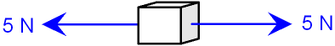 | 0N
- Calculate the resultant force acting on this object.  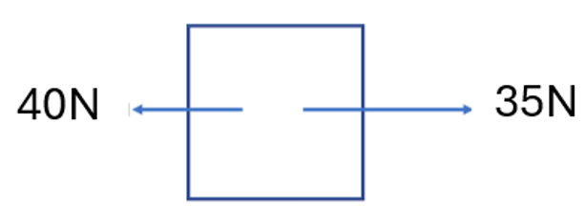 | 5N
- Calculate the resultant force acting on this object.  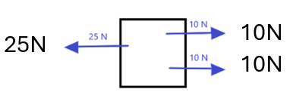 | 5N
- What are the three states of matter? | Solid, liquid, gas
- Which states of matter can flow? | Liquid and gas
- In which state of matter do particles vibrate on the spot? | Solid
- In which state of matter do particles have the most energy and move randomly? | Gas
- Which state of matter is the only one that can be compressed? | Gas
- What happens to pressure in a fluid as depth increases? | It increases because there is more fluid above.
- What happens to pressure in a fluid as you travel up higher into the air? | It decreases.
- What is upthrust? | An upward force from a fluid that helps things float.
- When upthrust force is equal to the weight of the object, what will happen to the object if it is in water? | Floats
- What is the formula for calculating the amount of pressure acting on an object. | Pressure = force ÷ area.
- What is the unit for pressure? | N/cm² OR N/m² OR N/mm²
- What is stretching? | Pulling something to make it longer.
- What is compression? | Pushing or squashing something to make it smaller.
- What is Hooke's Law? | The extension of a spring is directly proportional to the force applied, up to a limit.
- What is the spring constant? | A number that shows how stiff a spring is.
- What happens if you stretch a spring too much? | It can go past its limit and not return to its original shape.
- How do you calculate the extension of a spring? | Final length of spring - starting length of spring

