
OBHS Core Questions:
Subject: Science
Year and Term: Year 7 Cycle 1
Topic: 7C1 Properties of Matter and Separating Mixtures

Learn these questions to build a strong foundation of knowledge for this half-term. Ask family or friends to test you regularly, or practise on your own using the ‘Look, Say, Cover, Write’ method.

Core Question | Answer
- What is a particle? | A tiny object that makes up matter
- Draw a particle diagram for a solid | 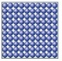
- Draw a particle diagram from a liquid | 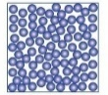
- Draw a particle diagram for a gas. | 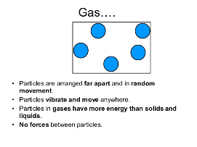
- What is a state of matter? | Whether it is a solid, liquid or gas.
- What is the name of the process of turning a solid into a liquid? | Melting
- What is the name of the process of turning a liquid into a gas? | Evaporation
- What is the name of the process of turning a liquid into a solid? | Freezing
- What is the name of the process of turning a gas into a liquid? | Condensation
- What is the name of the process of turning a solid into a gas? | Sublimation
- What is a mixture? | Different substances together but not chemically joined.
- Name four separation techniques | Filtration, crystallisation, chromatography, distillation
- Which separation technique is used to separate sand from water? | Filtration
- What does it mean if a substance is soluble? | The substance can dissolve in water
- Why is a pencil line used in chromatography? | So it doesn’t run (Pencil is insoluble and will not run up the paper)
- True or false, sand and water are separated using chromatography. | False, filtration would be used
- What does distillation separate? | Soluble solids from solution. Such as dye from water.
- What are the five main stages of distillation? | Heat, boil, evaporate, condense, collect
- Which separation technique would be used to separate pure water from salt water? | Distillation
- What is the definition of diffusion? | The movement of particles from a high concentration to a low concentration.
- What is density? | The number of particles in a given volume.
- If there are lots of particles in a given volume in a substance, is it likely to be very dense or not very dense? | Very dense
- Will dense objects sink or float? | Sink
- What is an element? | A substance made up of only one type of atom
- 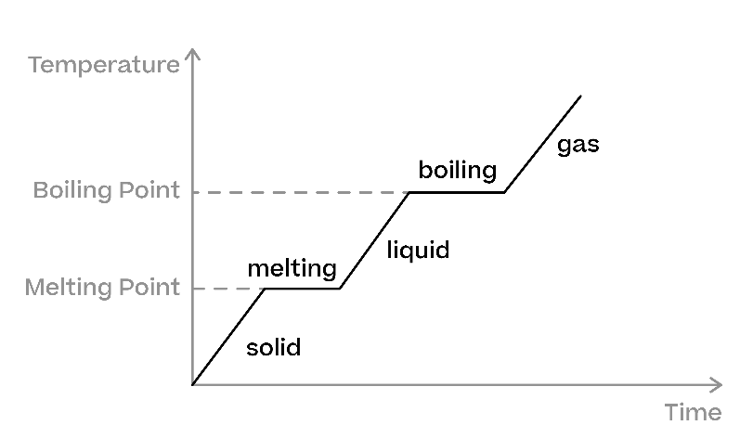On the heating curve above, what do the horizontal parts of the graph represent? | Changes of state

