
OBHS Core Questions:
Subject: Science
Year and Term: Year 7 Cycle 1
Topic: 7B1 Cells and Movement

Learn these questions to build a strong foundation of knowledge for this half-term. Ask family or friends to test you regularly, or practise on your own using the ‘Look, Say, Cover, Write’ method.
Core Question | Answer
- Name three parts of an animal cell? | Cytoplasm, cell membrane, nucleus, ribosomes, mitochondria
- Name three parts of a plant cell which are not found in animal cells. | Vacuole, chloroplasts, cell wall
- List three examples of specialised animal cells. | Sperm cell, egg cell, muscle cell, nerve cell, red blood cell.
- What is the function of the nucleus? | Controls the activities of the cell OR contains the DNA
- What is the function of the cell wall? | Supports the plant cell
- What is the function of the cytoplasm? | Jelly-like substance where chemical reactions take place
- What is the function of the chloroplasts? | Absorb light for photosynthesis
- What is the function of the cell membrane? | Allows substances in and out of the cell
- How many cells is a uni-cellular organism made up of? | One cell
- How many cells is a multi-cellular organism made up of? | Many cells
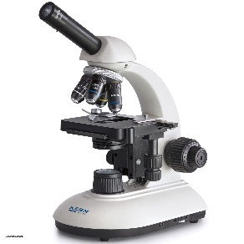  - What is the name of this piece of equipment? | Light microscope
- By which process do substances move into and out of cells? | Diffusion
- Define diffusion. | The movement of substances from an area of high concentration to an area of low concentration
- What are the four main functions of the human skeleton? | - Make blood cells  - Protection  - Support  - Movement
- What is a joint? | Places where bones meet
- What is the name for a pair of muscles where one muscle contracts as the other relaxes? | Antagonistic
- What connects bones together in joints? | Ligament
- What connects muscle to bone? | Tendon
- What is the name of the smooth tissue found at the end of bones, preventing bones from rubbing together? | Cartilage
- What is the name of the long bone found in the upper leg? | Femur
- What is the name of the long bone found in the upper arm? | Humerus
- What is the name of the bone which protects the brain? | Skull
- What is the name of the bones which protect the lungs? | Ribs
- Where is the smallest bone in the body found? | Inner ear
- Where are new blood cells made? | In the bone marrow

