 | Question | Answer
1. | What is a composer? | Someone who writes music
2. | What is a suite? | A collection of short musical pieces or movements that are performed together.
3. | What is a movement? | A main section of a longer piece of music.
4. | What is a crescendo? | A gradual increase in volume. The music gets louder.
5. | What is an ostinato? | A short musical pattern that is repeated throughout a piece of music.
6. | Can you name the eight elements of music? | Pitch, Tempo, Dynamics, Duration, Texture, Timbre, Articulation and Silence
7. | What is Pitch in music? | How high or low a sound is.
8. | What is Tempo in music? | The speed of a piece of music.
9. | What are Dynamics in music? | How loud or quiet the music is
10. | What is Duration in music? | How long a sound or note lasts.
11. | What is Texture in music? | How many layers of sound there are in a piece of music and how they work together.
12. | What is Timbre in music? | The unique sound or tone quality of an instrument or voice.
13. | What is Articulation in music? | How notes are played, for example legato (smooth) or staccato (short and detached).
14. | What is Silence in music? | The absence of sound. In music, silence is shown using rests.
15. | What is a Instrumentation in music? | Instrumentation is the choice and combination of instruments and voices used in a piece of music.
16. | I can name the notes on a piano keyboard. | 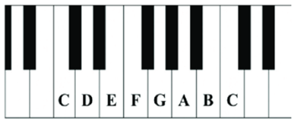
17. | How many beats is this note worth? | 4 beats
18. | How many beats is this note worth? | 2 beats
19. | How many beats is this note worth? | 1 beat
20. | 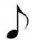  How many beats is this note worth? | ½ beat
OBHS Core Questions:
Subject: Music
Year and Term: Year 8 Autumn Cycle 1
Topic: Music and Space
Learn these questions to build a strong foundation of knowledge for this half-term. Ask family or friends to test you regularly, or practise on your own using the ‘Look, Say, Cover, Write’ method.

