 | Question | Answer
1. | Match the following events with their probability on the scale:  a) It will rain tomorrow.  b) You will roll a 7 on a standard six-sided die.  c) You will win the lottery.  (Certain, Very likely, Equally likely, Impossible, Not likely, etc.) | - Equally likely  - Impossible  - Unlikely/impossible (under 16)
2. | 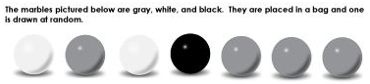  - Which colour is least likely to be selected?  - What is the probability of choosing a black marble?  - What is the probability of choosing a white OR a black marble? | - Black  - $\frac{1}{7}$  - $\frac{3}{7}$
3. | A restaurant offers 3 starters, 5 mains and 4 deserts to choose from on its menu. If I ordered a starter, a main and a desert how many different combinations are there? | 3 x 5 x 4 = 60 combinations
4. | A starter menu at a restaurant offers Mushrooms, Prawns or Soup. For mains they offer Lamb or Pasta. Write the combinations that could be ordered. | ML, MP, PL, PP, SL or SP
5. | What does the sum of all probabilities total to? | 1 or 100%
6. | In a group of 100 students, 60 students prefer chocolate ice cream. What is the relative frequency of students who prefer chocolate ice cream? | $$\frac{60}{100}$$
7. | Use this spinner to find the following: - P(1)=  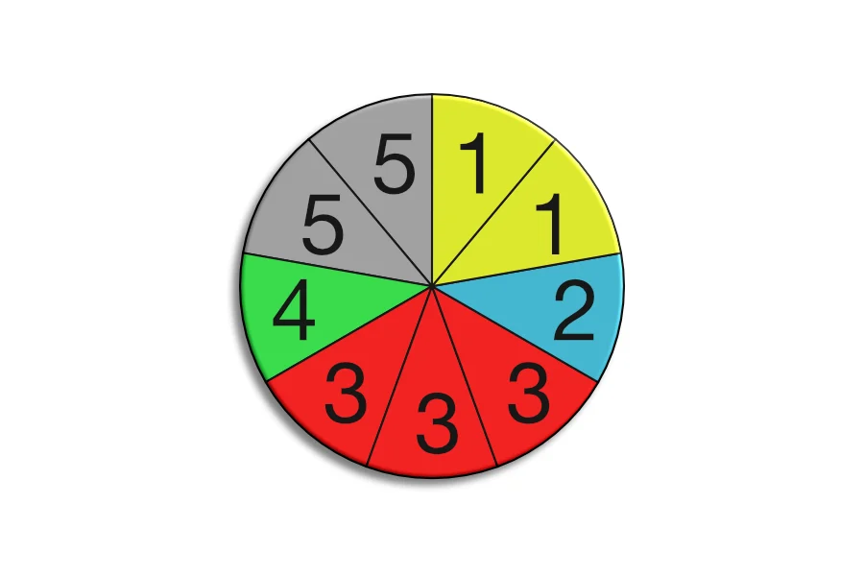  - P (EVEN)=  - P (PRIME) = | P(1) = $\frac{2}{9}$  P (EVEN) =$\frac{2}{9}$  P (PRIME) = $\frac{6}{9}$
8. | 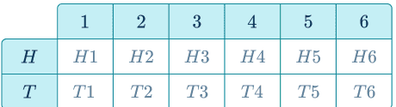  Above is a sample space diagram when flicking a coin and rolling a fair 6-sided dice. Use the sample space diagram to find the probability of Heads and a 5? | $$\frac{1}{12}$$
9. | 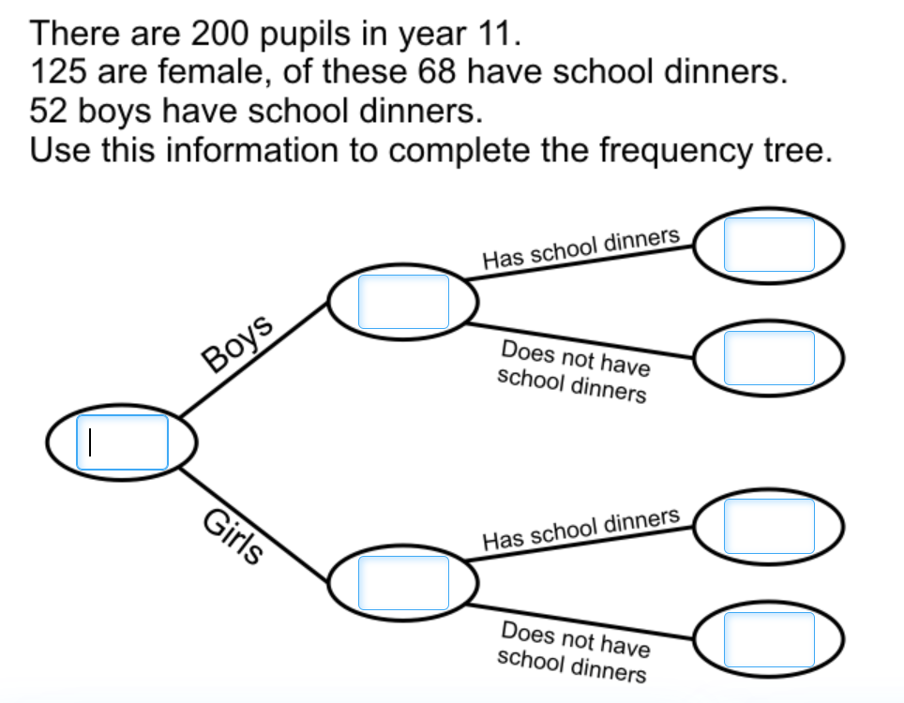 | 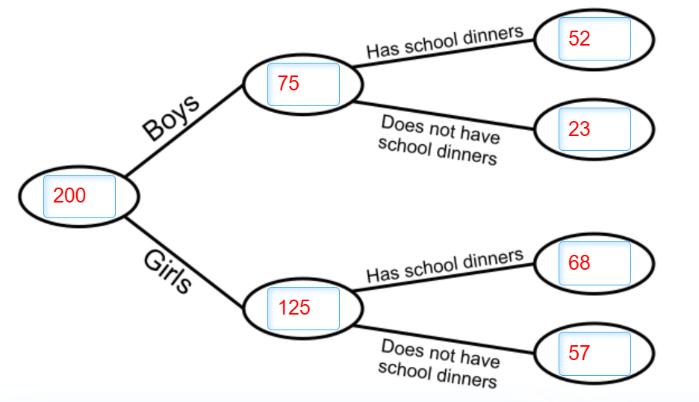
10. | 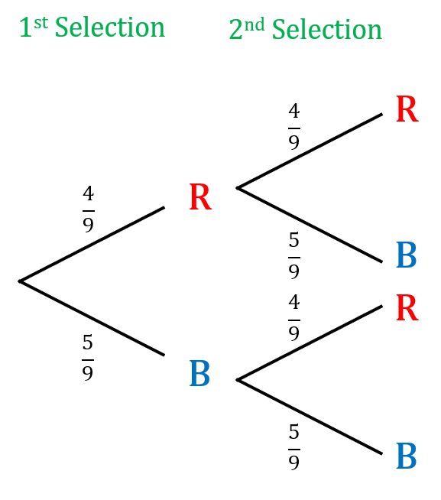  Use this tree diagram to find the probability of getting 2 reds. | RR = $\frac{4}{9}$ $×\frac{4}{9}$  = $\frac{16}{81}$
11. | 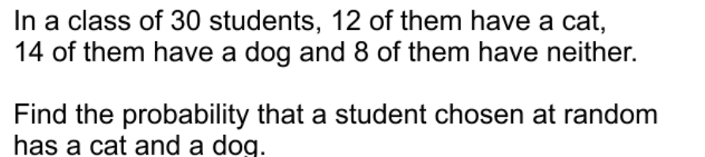 | 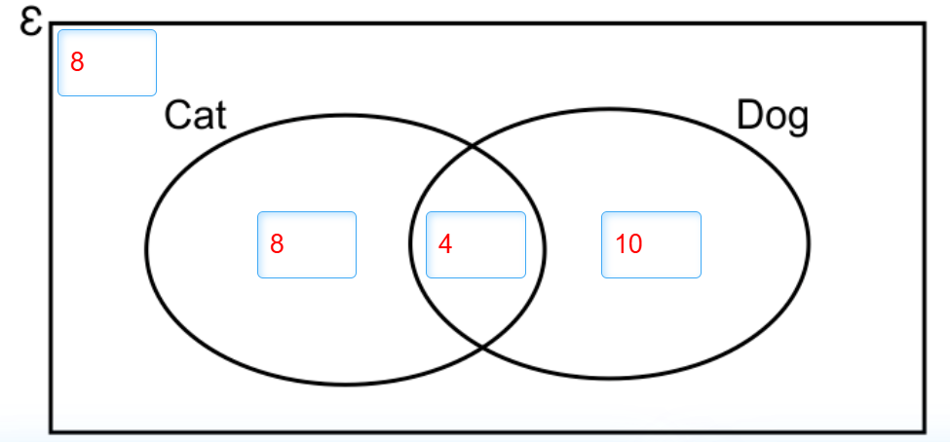  Probability (C and D) = $\frac{4}{30}$
OBHS Core Questions:
Subject: Maths
Year and Term: Autumn 2 year 9
Topic: SP3
Learn these questions to build a strong foundation of knowledge for this half-term. Ask family or friends to test you regularly, or practise on your own using the ‘Look, Say, Cover, Write’ method.

