 | Question | Answer
1. | What is the Area of a Rectangle formula… | Area = length x width.
2. | What is the Area of a Triangle Formula … | (1/2) x base x height.
3. | What is the Area of a Circle Formula ….. | Area = π x radius
 | What is the Area of a Trapezium Formula….. | ½ (a+b)xheight
4. | What is a composite (or compound) shape? | A shape made up of more than 1 shape
5. | What is the diameter? | All the way across the middle of a circle – twice the radius
6. | What is the area of a rectangle with a length of 8cm and a width of 5cm? | 40cm²
7. | A square has a side length of 12mm. What is its area? | Area of square = side length squared.  12 squared = 144mm²
8. | 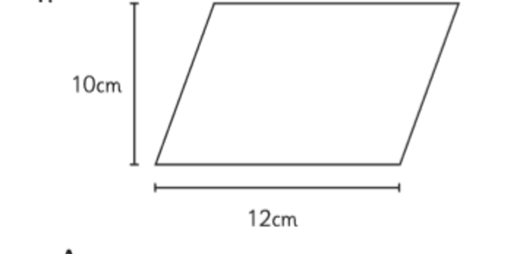  What is the area of this parallelogram? | Area of parallelogram = base x perpendicular height  10 x 12 = 120 cm²
9. | A triangle has a base of 10m and a height of 4m. What is its area? | Area of triangle =  (base x perpendicular height) ÷ 2  (10x4) ÷ 2 = 20m²
10. | 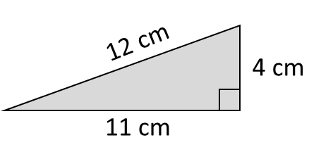  Find the area of this triangle | (11 x 4) ÷ 2 = 22 cm²
11. | 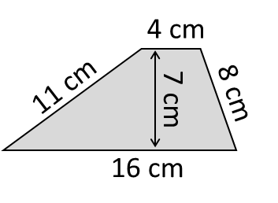  Find the area of this Trapezium | Area of trapezium =  ½ (a+b) h  Therefore: ½ x (4+16) x 7=70 cm²
12. | A circle has a radius of 5 cm. Calculate its area, giving your answer in terms of π | Area of circle = π x r²  π x 5² =25 π
13. | A rectangular wall is 5 meters long and 3 meters high. How much paint is needed to cover the wall if one litre of paint covers 2 square meters? | 7.5 litres
14. | 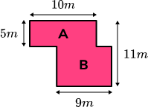  Find the area of this compound shape | A = 5 X 10  = 50 m²  B = 11 – 5 = 6  = 6 X 9  = 54m²
²OBHS Core Questions:
Subject: Maths
Year and Term: Spring 2 yr 8
Topic: GM3
Learn these questions to build a strong foundation of knowledge for this half-term. Ask family or friends to test you regularly, or practise on your own using the ‘Look, Say, Cover, Write’ method.

