 | Question | Answer
1. | What media did David Hockney use in his landscapes | Digital, photography, paints.
2. | What is meant by the term ‘mixed media’ | Using more than one art material in a piece.
3. | What is the sgraffito technique? | Scratching through a surface to reveal a layer underneath. Normal using wax crayons and oil pastels.
4. | What is wax resist, and what materials are commonly used to create it? | A technique using wax (e.g., crayon) to resist paint e.g. Water-based paint cannot stick to wax.
5. | What are two advantages of using watercolour when creating landscapes? | Transparent layers, easy colour blending, soft effects.
6. | What is a collage? | Artwork made by sticking materials onto a surface.
7. | What does collaboration mean in art? | Working together with others to create art.
8. | Describe one benefit of working collaboratively on a project. | Sharing ideas, improving skills, larger artwork, supporting each other.
9. | What is the rule of thirds? | It helps place focal points and creates balance.
10. | Show how the rule of thirds work.  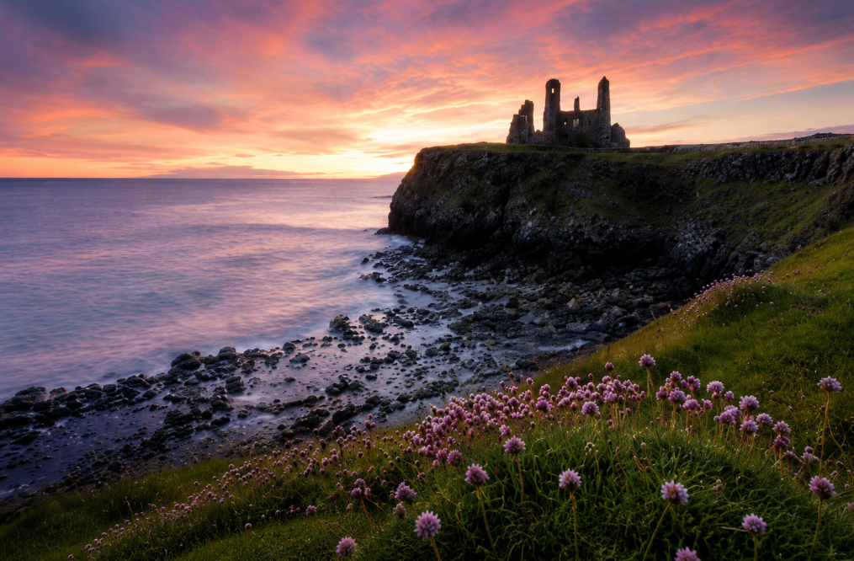 | 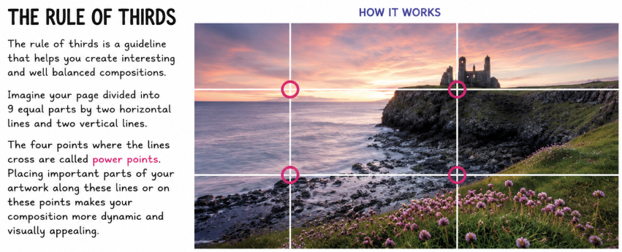
OBHS Core Questions:
Subject: Art
Year and Term: Year 9 Unit 2
Topic: Landscape
Learn these questions to build a strong foundation of knowledge for this half-term. Ask family or friends to test you regularly, or practise on your own using the ‘Look, Say, Cover, Write’ method.

