 | Question | Answer
1. | What is a hue? | Pure colour that hasn’t been brightened or darkened.
2. | What is a tint? | The addition of white to lighten a hue creates a tint.
3. | What is a shade? | The addition of black to darken a hue creates a shade.
4. | What are adjacent colours called? | Harmonious colours.
5. | What is composition? | The arrangement of the formal elements to complete a whole
6. | What does VP mean | Vanishing point in perspective drawing. This is where the all lines will go to.
7. | 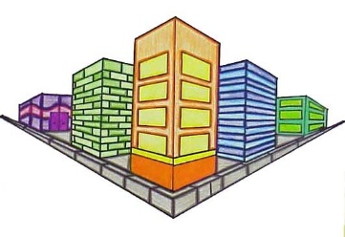  Which style of drawing does this show? | 2 point perspective
8. | 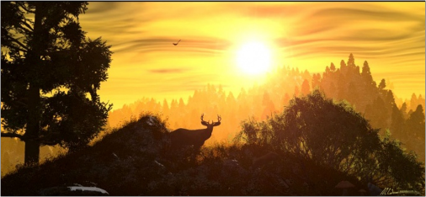  Label the background, foreground and midground | 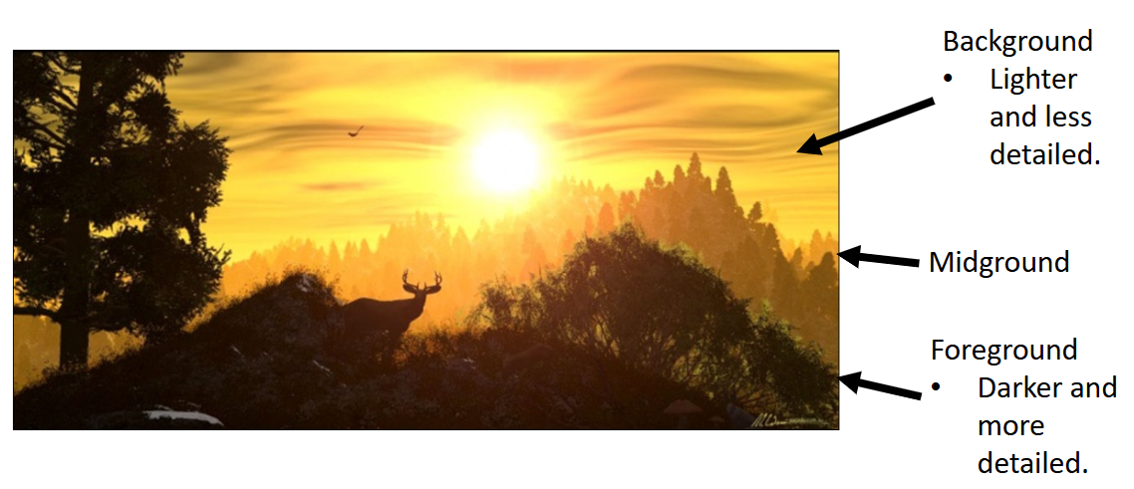
9. | 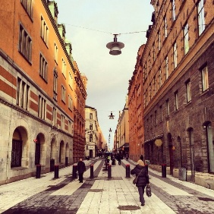  Which style of drawing does this show? | 1 point perspective
10. | What was the name of the artist who could see sound and hear colour? | Wassily Kandinsky
11. | The art movement that created illusions in the 1950s-60s was called? | Op Art
12. | The famous women artist for Op Art was? | Bridget Riley
13. | Op Art (Optical Art) is a style of abstract art that uses what? | Precise geometric patterns, shapes, and colour theory
14. | 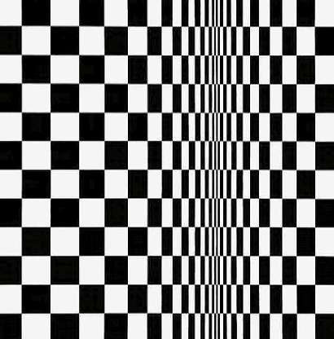 How would you describe the composition of this piece of Bridget Rileys work. | The pattern is made of black and white squares. Bridget Riley changes the size of the squares so they become thinner in the middle. This makes the picture look like it is bending or moving, even though it is flat. The repeated squares create order.  Riley uses strong black and white colours which makes the pattern stand out clearly. The changing shapes make your eyes feel like the image is shifting or vibrating creating the movement of an optical illusion.
OBHS Core Questions:
Subject: Art
Year and Term: Year 8 Spring term
Topic: Perspective drawing
Learn these questions to build a strong foundation of knowledge for this half-term. Ask family or friends to test you regularly, or practise on your own using the ‘Look, Say, Cover, Write’ method.

